

A MAJOR PROJECT REPORT ON
“COVID-19 LIVE TRACKER”

SUBMITTED TO
DEPARTMENT OF COMPUTER SCIENCE

Submitted within the partial fulfillment for the award of degree of

“MASTER OF COMPUTER APPLICATION”
(BATCH - 2019-2021)

Under the Direction of
MISS CHITRANGADA CHAUBEY (PROJECT GUIDE)

SUBMITTED BY

DINESH KUMAR Enroll. No. (1902209008)
MANISH Enroll. No. (1902209015)

28, K. M. Stone Mathura, Chennai - Delhi Highway, Chhata Rural, Uttar-Pradesh 281401

DECLARATION

This is to certify that the Project / Thesis / entitled “Covid-19 Live Tracker” in partial fulfillment of the requirement for the award of the Degree of Master of Computer Application in Sanskriti University, Chhata (Mathura) submitted to, Sanskriti University, Chhata, (Mathura) India, is an authentic record of bonfire work carried out by me and my partners under
the supervision /guidance of Miss. Chitrangada chaubey.

The matter embodied Project/Thesis/Dissertation has not been submitted for the award of degree or diploma to any University/Institution.

Date: 25/June/2021 Signature Name of Candidate

MANISH Enroll No.- 1902209015 DINESH KUMAR Enroll No. - 1902209008


CERTIFICATE

This is to certify that the Project/Thesis entitled “Covid-19 Live Tracker” is submitted by Manish, Dinesh Kumar in partial fulfillment of the requirement for the award of the Degree Master of Computer Application,
in Sanskriti University, Chhata (Mathura) submitted to, Department of Computer Science & Engineering School of Engineering Sanskriti University, Chhata, (Mathura) India, is an authentic record of bonafide project work carried out by them under my supervision/ guidance.

To the simplest or best of my knowledge, the matter embodied within the thesis has not been submitted to the other University/Institute for the award of any Degree or Diploma.

Date: 25/June/2021 Signature and Name of Supervisor(s)/Guide

Place

ACKNOWLEDGEMENT

This project was an ambitious work and would haven’t been completed without the facilities provided by the Miss. Chitrangada Chaubey Department of Computer Science in Sanskriti University and the co-operation of my parents and sincere efforts of my faculty colleagues guided me helped this project. My sincere “THANKS” goes to:

I was to precise my gratitude and sincere because of our Faculty and HOD of dept. Mr. Pankaj Saraswat for providing better working environment for competing this project successfully.
I am also thankful to all faculties i.e. Miss. Chitrangada chaubey, Mr. Pankaj Sarswat, Mr. Mrinal Paliwal and also Mr.Swapnil sir
Lastly, I want to give thanks to my parents and everyone of my friends for uplifting my spirit to attain this goal.

Content

Sr. | Content | Page No.
1 | Introduction
1.1 | Introduction Covid-19 | 07
1.2 | Pandemic | 07
1.3 | Problem Statement | 08
2 | Literature Survey
2.1 | Research Papers Referred | 10
2.2 | Data Source | 10
3 | Data & Preprocessing
3.1 | Data Description | 12
3.2 | Technologies Used | 14
3.3 | Data Pre-Processing | 14
3.4 | Data Exploration | 15
4 | Analysis
4.1 | Analysis | 17
4.2 | R Factor | 22
4.3 | Doubling Rate | 23
4.4 | Death Rate | 24
4.5 | Recovery Rate | 25
4.6 | Cluster Analysis | 26
4.7 | Lockdown Analysis | 29
5 | Coding Section and Screenshots | 33
6 | Conclusion
6.1 | Conclusion | 37
6.2 | Future Enhancement | 39


4LIST OF DIAGRAM

Sr.No. | Figure No. | Chart Name
1 | 4.1 | Total Cases Time Series
2 | 4.2 | Percentage Rate
3 | 4.3 | Gender Rate
4 | 4.4 | Global Test Rate
5 | 4.5 | Lockdown Phase Time Series
6 | 4.6 | State Comparison
7 | 4.7 | Confirm Cases Map
8 | 4.8 | R0 Factor
9 | 4.9 | Doubling Rate
10 | 4.10 | Death Rate
11 | 4.11 | Recovery Rate
12 | 4.12 | Urban Population Map
13 | 4.13 | GDP India Map
14 | 4.14 | Lockdown Comparison

5

CHAPTER 1

INTRODUCTION

6
  - INTRODUCTION:
Coronavirus disease 2019 (COVID-19) is a communicable disease caused by severe acute respiratory syndrome coronavirus 2 (SARS-CoV-2). It was first identified in December 2019 in Wuhan, China, and has resulted in an ongoing pandemic. The first case may be traced back to 17 November 2019. As of 8 June 2020, quite 6.98M cases are reported across 188 countries and territories, leading to quite 401,000 deaths. More than 3.13 million people have recovered.
The virus is primarily spread between people during close contact, most frequently via small droplets produced by coughing, sneezing, and talking. The droplets usually fall to the bottom or onto surfaces instead of travelling through air over long distances. Less commonly, people may become infected by touching a contaminated surface then touching their face. It is most contagious during the primary three days after the onset of symptoms, although spread is feasible before symptoms appear, and from people that don’t show symptoms
The virus is primarily spread between people during close contact, most frequently via small droplets produced by coughing, sneezing, and talking. The droplets usually fall to the bottom or onto surfaces instead of travelling through air over long distances. Less commonly, people may become infected by touching a contaminated surface then touching their face. It is most contagious during the primary three days after the onset of symptoms, although spread is feasible before symptoms appear, and from people that don’t show symptoms.

  - PANDEMIC :
The COVID-19 pandemic, also mentioned because the coronavirus pandemic, is an ongoing pandemic of coronavirus disease 2019 (COVID-19), caused by severe acute respiratory syndrome coronavirus 2 (SARS-CoV-2). The outbreak was first identified in China(Wuhan), in December 2019. The World Health Organization(WHO) declared the outbreak a Public Health Emergency of International Concern(PHEIC) on 30 January, and a epidemic on 11 March.
A global coordinated effort is required to prevent the further spread of the virus. An plague is defined as “occurring over an entire geographic area and affecting an exceptionally high proportion of the population.” The last pandemic reported within the whole world was the H1N1 flu pandemic in 2009.

7
Coronaviruses are important human and animal pathogens. At the in end of 2019, an unique novel coronavirus was identified because the explanation for a cluster of pneumonia cases in Wuhan, a city within the Hubei Province of China. It rapidly spread, leading to an epidemic throughout China, followed by

an increasing number of cases in other countries throughout the whole earth. On 30 January 2020 India recorded its first COVID-19 case in state of Kerala. It was a student who had travel history to china. And till the beginning of June India has over 200 thousand confirmed cases.

  - PROBLEM STATEMENT:

In this report of project we dived deep into ‘What does data say about Covid-19 situation in India?’. And with available data we came up with some conclusions and observations.
This analysis mainly focuses on:

✔ First is what is the current COVID-19 situation in India?
✔ Second is state-wise comparison.
✔ Third is what could be the reasons behind cases clusters found in India.
✔ And last is lockdown in India successful or not?

Figure(1.1)

8

.

CHAPTER 2

LITERATURE SURVEY

9

  - RESEARCH PAPER REFERRED
    - The Covid-19 impact on Indian Economy Authers:
      - S. Mahendra Dev (Indira Gandhi Institute of Development Research)
      - Rajeshwari Sengupta (Indira Gandhi Institute of Development Research) https://ideas.repec.org/p/ind/igiwpp/2020-013.html
    - COVID-19 in India: Potential Impact of the Lockdown and Other Longer-Term Policies
Authers:

- Emily Schueller
- Eili Klein(Department of Emergency Medicine) Johns Hopkins School of Medicine
- Gary Lin (Department of Emergency Medicine John Hopkins School of Medicine)

https://cddep.org/wp-content/uploads/2020/04/India-Shutdown-Modeling-Slides-Final-2.pdf


  - DATA SOURCES

For the COVID-19 data we’ve scrapped https://api.covid19india.org which may be a volunteer-driven, a crowdsourced database for COVID-19 stats & patient tracing in India .

For facts and knowledge we’ve referred www.wikipedia.com and www.twitter.com .

10

CHAPTER 3

DATA &
PRE-PROCESSING

11
  - DATA DISCRIPTION
Data contains multiple files which incoporates

Raw_data : It’s all complete raw information about COVID-19 in India.

Having Columns ['agebracket', 'backupnotes', 'contractedfromwhichpatientsuspected', 'currentstatus', 'dateannounced', 'detectedcity', 'detecteddistrict', 'detectedstate', 'estimatedonsetdate', 'gender', 'nationality', 'notes', 'numcases', 'patientnumber', 'source1', 'source2', 'source3', 'statecode', 'statepatientnumber', 'statuschangedate', 'typeoftransmission', 'entryid']

State_wise_data : It has state wise data of COVID-19.

Having Columns ['active', 'confirmed', 'deaths', 'delta_confirmed', 'delta_deaths', 'delta_recovered', 'last_updated_time', 'migrated_other', 'recovered', 'state', 'state_code', 'state_notes']

Daily_data : It has number of patients recorded on daily basis.

Having Columns ['daily_confirmed', 'daily_deceased', 'daily_recovered', 'date', 'total_confirmed', 'total_deceased', 'total_recovered']

Test_data : Tests confirmed in every state.

Having Columns ['individual_stestedper_confirmed_case', 'positive_cases_from_samples_reported', 'sample_reported_today', 'source', 'test_positivity_rate', 'tests_conducted_by_privatelabs', 'tests_perconfirmed_case', 'testsper_million', 'total_individual_stested', 'total_positive_cases', 'totalsamples_tested', 'update_timestamp']

State_wise_GDP : All States GDP of 8 years.

12
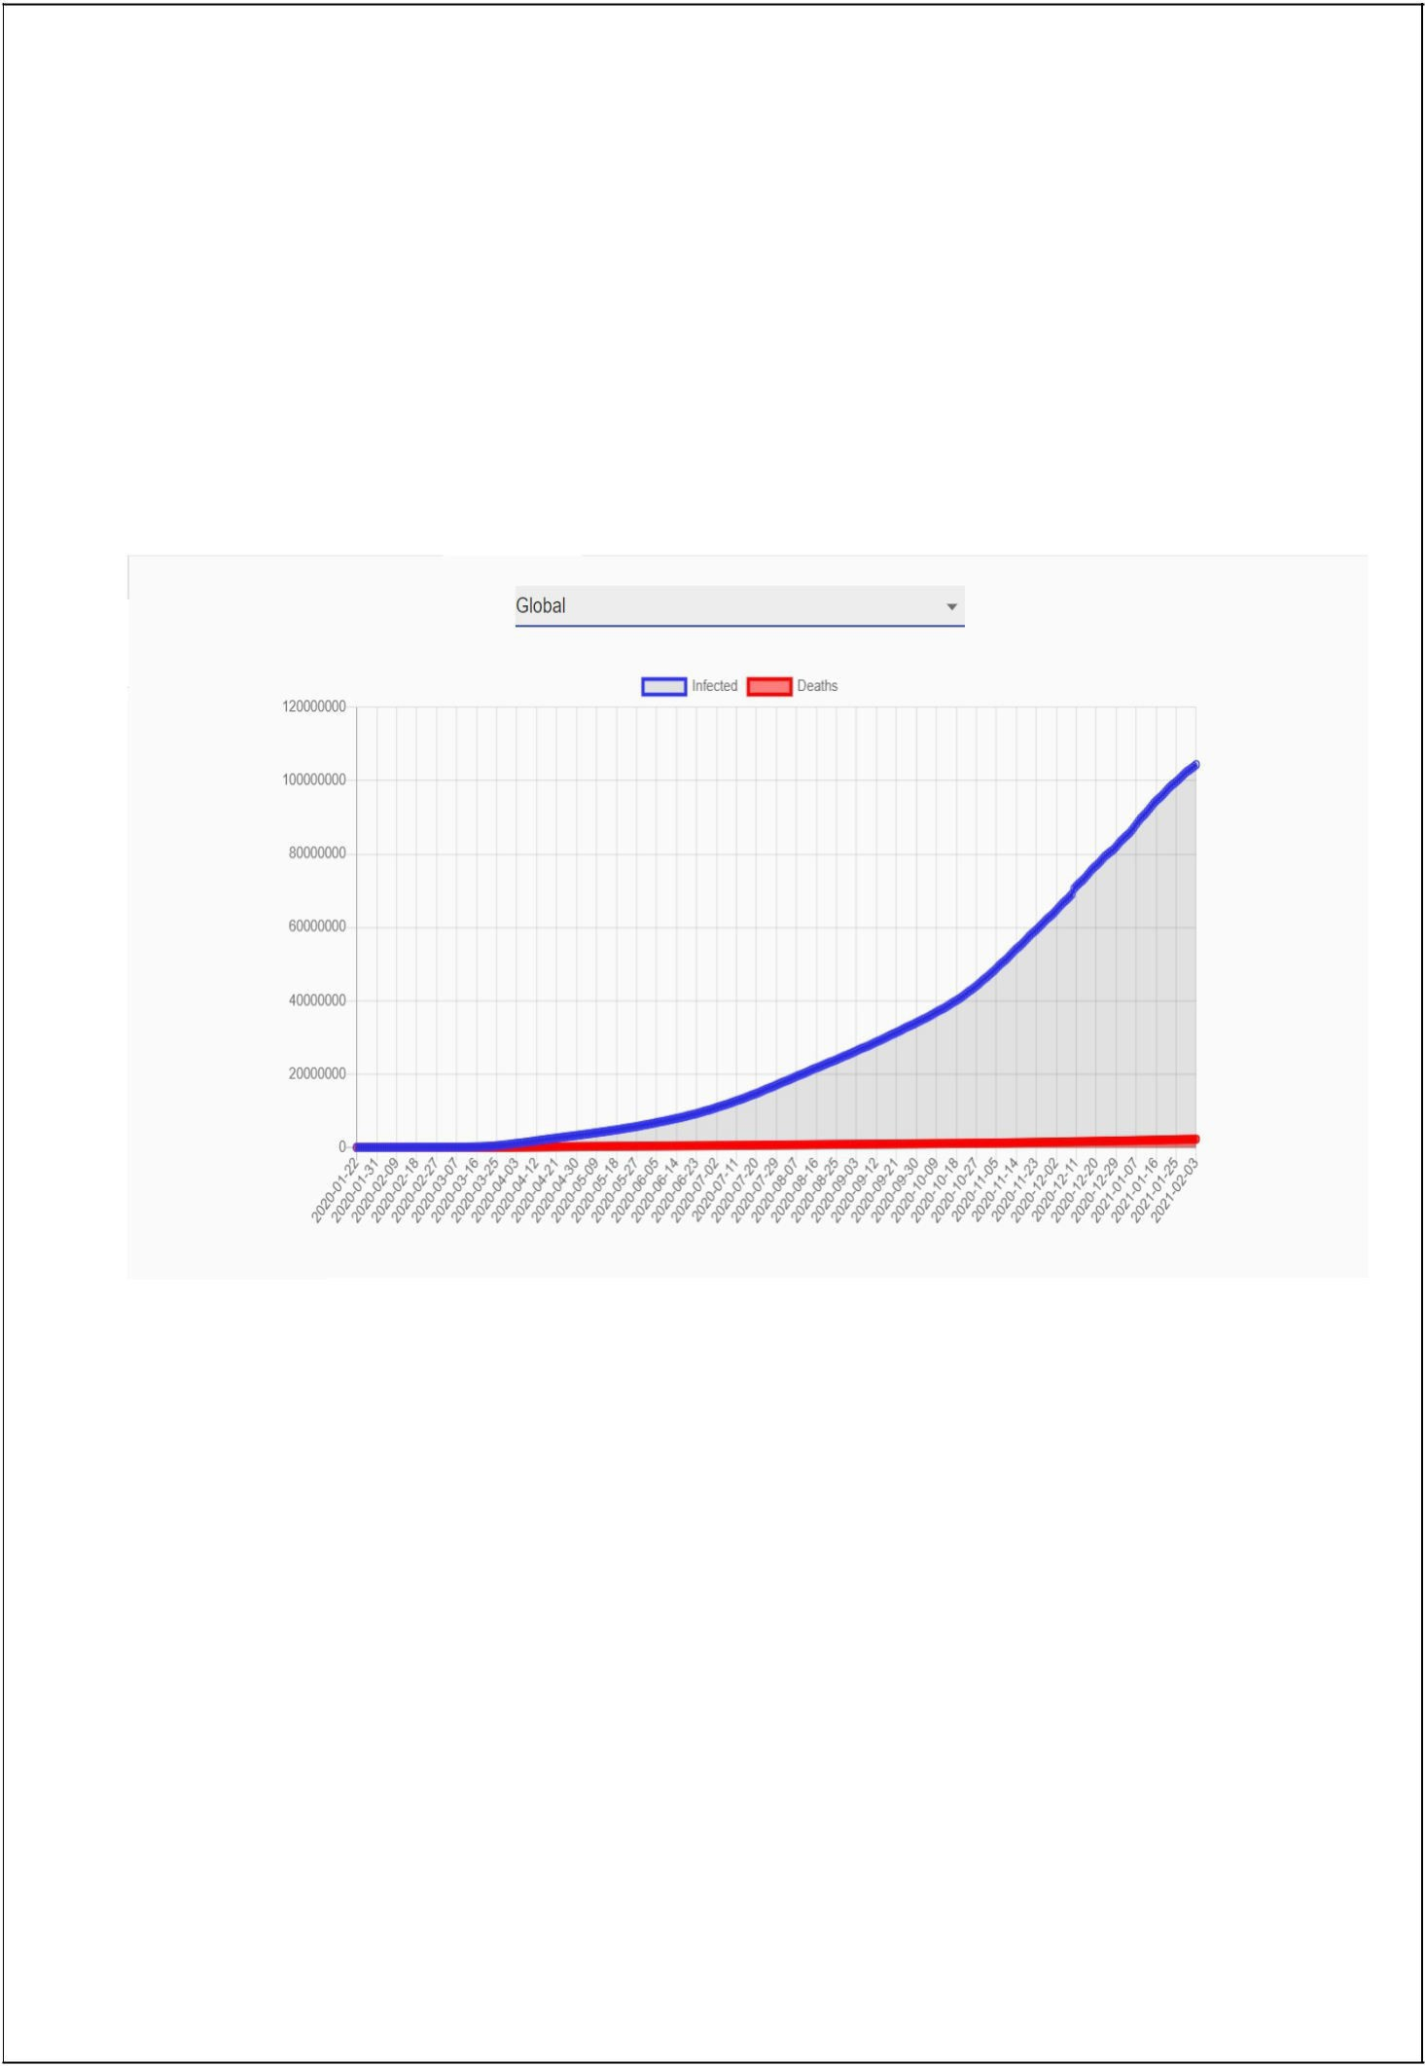
Having Columns ['state/ut', '2019-2020']

State_wise_Population : All states’ population according to 2011 Census Having Columns ['state/ut', 'Population', 'DecadalGroth', 'RuralPopulation',
'UrbanPopulation', 'Area', 'Density', 'Sexratio'

Figure(2.1)

13

  - TECHNOLOGIES USED
Python is the best and suitable programming language for visualization, preprocessing, scrapping , etc.
Libraries Used :
    - Scrapy : Scraping is a python framework for large web scraping. It gives all complete tools for extract data
    - Pandas : Working with data files. It is very fast and powerful and also flexible and easy
    - Numpy : for Scientific Calculation( It is fundamental module for scientific calculation)
    - Matplotlib : Basic plotting library for mathematics visualization
    - Plotly : Advance interactive open source library for graph objects Visualization
    - Dash : Creating Dashboard

Tableau for visualization.
It is an American data visualization soft company. It is powerful visualization tool which allow us to plot geo-informatical Data.

  - DATA PRE-PROCESSING

Data preprocessing is a data mining and data processing technique that transform raw data into clear and an understandable format. Real-world data is usually incomplete, inconsistent, and/or lacking in certain behaviors or trends, and data preprocessing is probably going to contain many errors. Data preprocessing is also a proven method or machenism of resolving such types of issues. It prepares raw data for below processing.

Steps are using :
- Scrappeded data was in raw form and all information was in a single file. So here we needed to make completely separated files based on their purpose.
- Death rate of each state is calculated or manipulate by the formula (no. of deaths/ no. of total confirmed cases)*100.

- Recovery rate of each state is manipulated or calculated by the formula (no. of recoveries / no. total confirmed cases)*100.

- Devided the data according to the lockdown times or periods.
- Null values of state wise Gross Domestic Product(GDP) data filled with average.

14

3.1 DATA EXPLORATION

    - TYPES OF VISUALIZATION USED

Pie chart: Use too show recovered, active, death percentage due to COVID -19and gender distribution.

Bar Plot: Use to show state simulation on various factors, age-wise distribution etc.

Line Plot : Use to show recovered, confirmed, deceased trend on daily basis.

3D plot: Use to show confirmed cases state wise daily count.

    - TECHNOLOGIES USED FOR VISUALIZATION

Python modules and Tableau are used to create all the visualizations which are displayed on the page.

Plotly and matplotlib modules are the python libraries for simple and advance visualization used for the visualization

15

CHAPTER 4 ANALYSIS

16
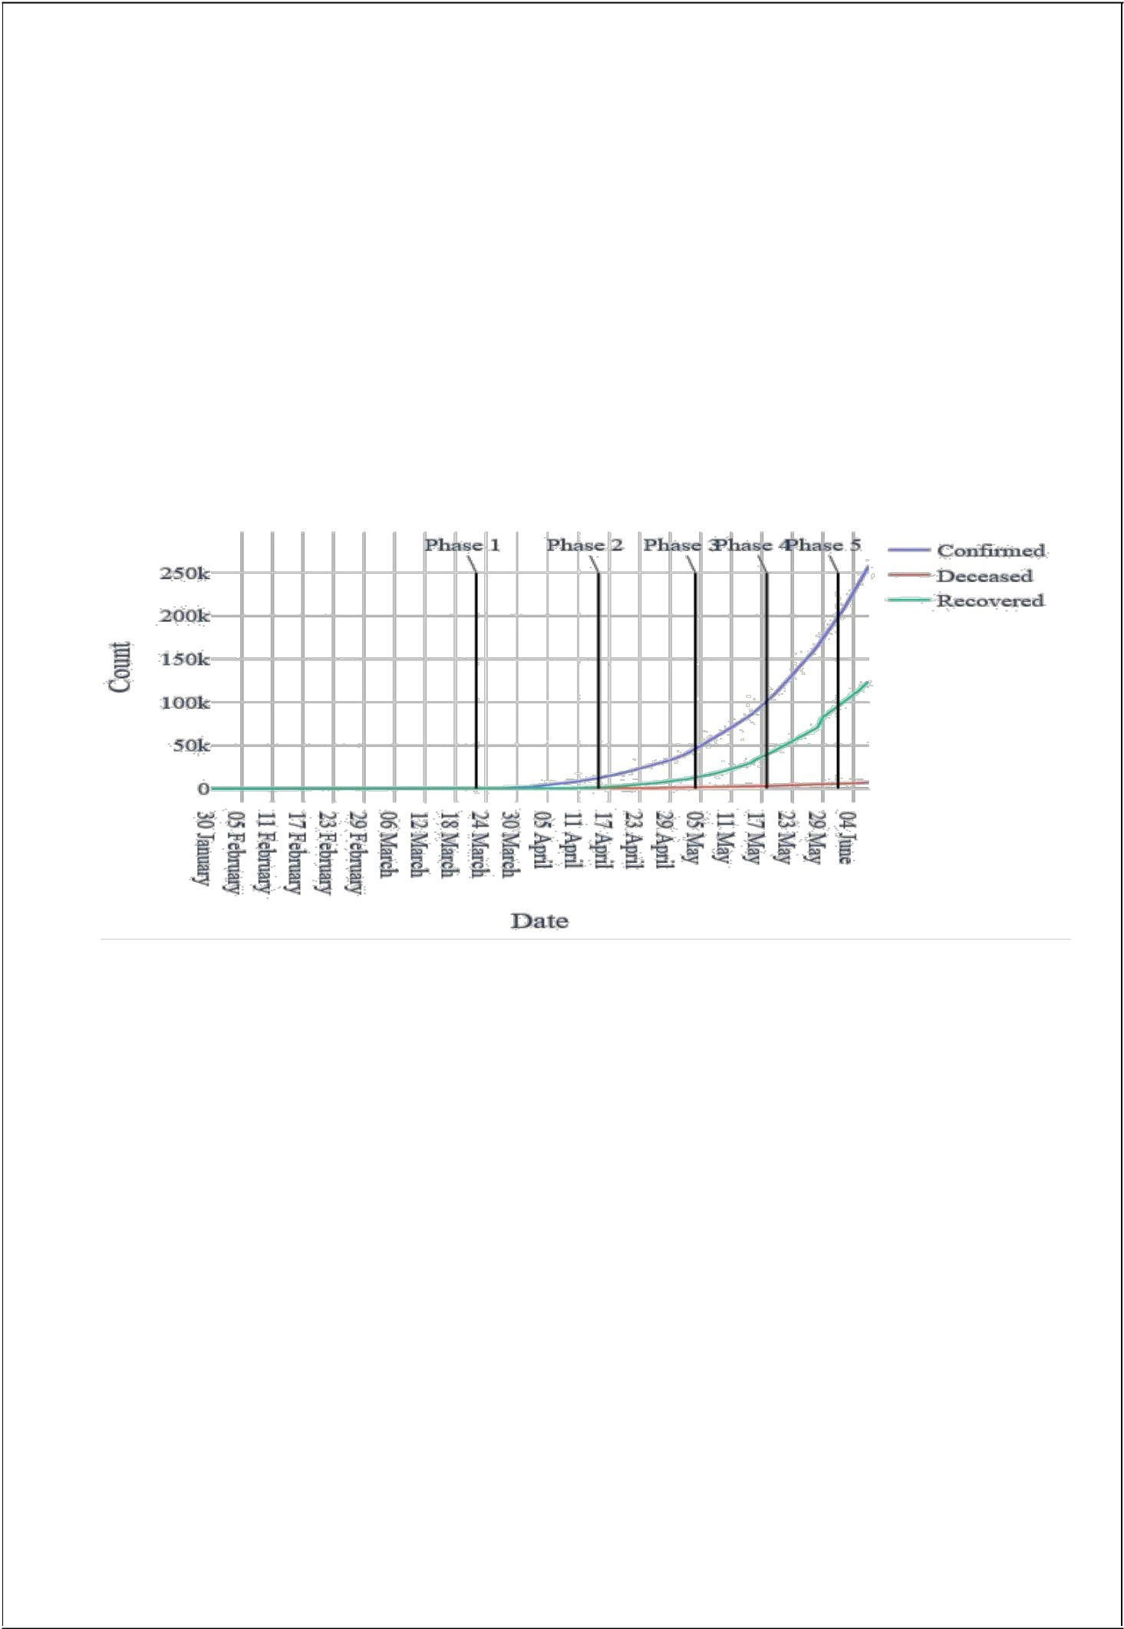
  - ANALYSIS ( IMPLEMENTATION )

In India first COVID-19 recorded case on 30th

January 2020 in kerala. The infected
was a student who had travelled to china for higher studies. And since then cases in India is rising continueously.

A complete Dashboard is released on http://siddfulzele.pythonanywhere.com/covid_India/

What is the current situation in India?

( Fig 4.1 )th

As shown above, India had recorded over 500 cases till 24 March. This lockdown also known as Lockdown 1.0 So government declared lockdown from 25th march to 14
and after this government has been extending lockdown step by step.

Situation in India till 24th June 2021.

- Confirm Cases : 30,028,709
- Recovered :28,994,855
- Active : 1033854
- Deaths: 390660

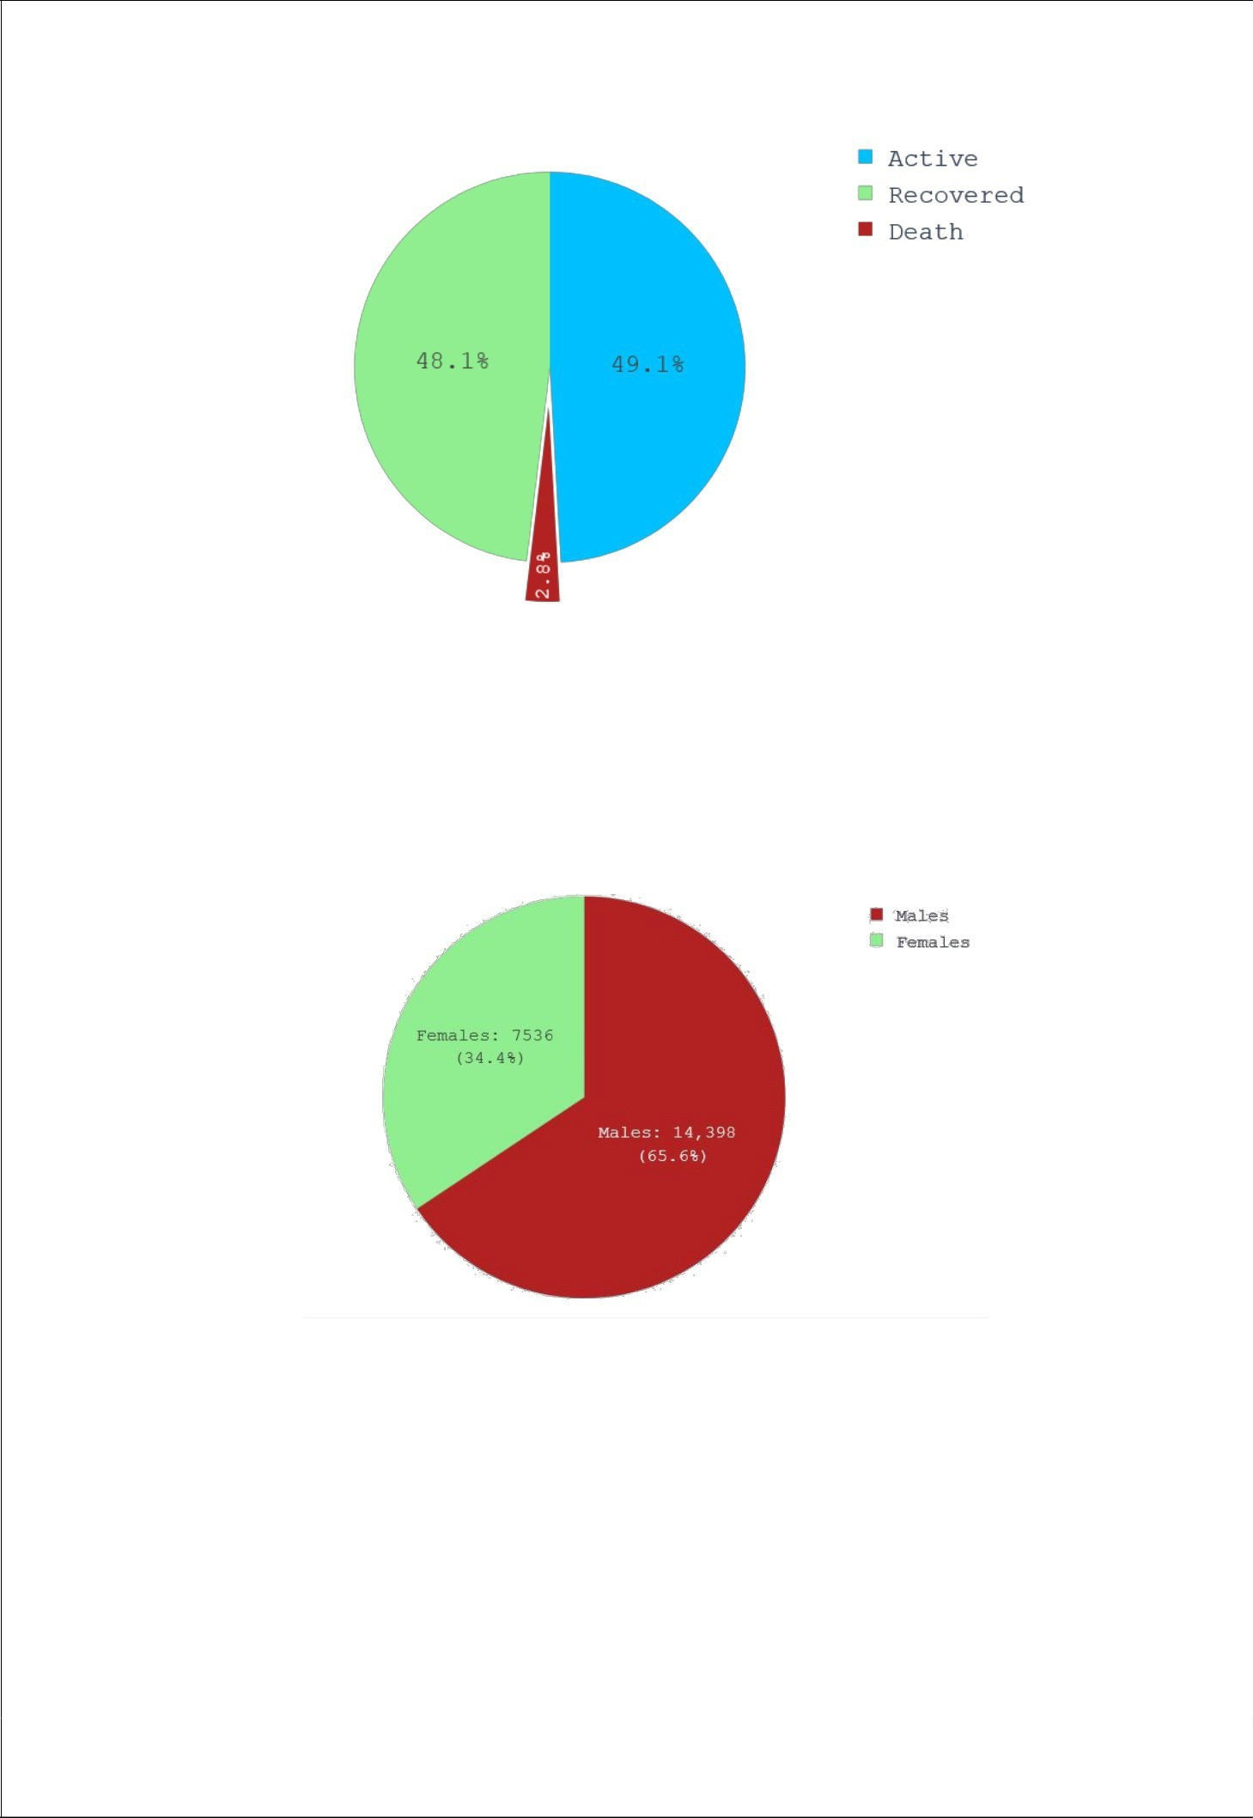

( Fig 4.2 )

India is showing good recovery rate day by day with low rate of deaths but on the opposite or other hand it’s also reaching new peak of confirmed cases day by day.

If we talk at the extent of patients then as per sample size 21936 cases,

( Fig 4.3 )

As shown above in the figure, number of infected females is less than that of males. It may be also a reason behind this is the more exposure of males in Indian family to outside work could be the reason behind this.

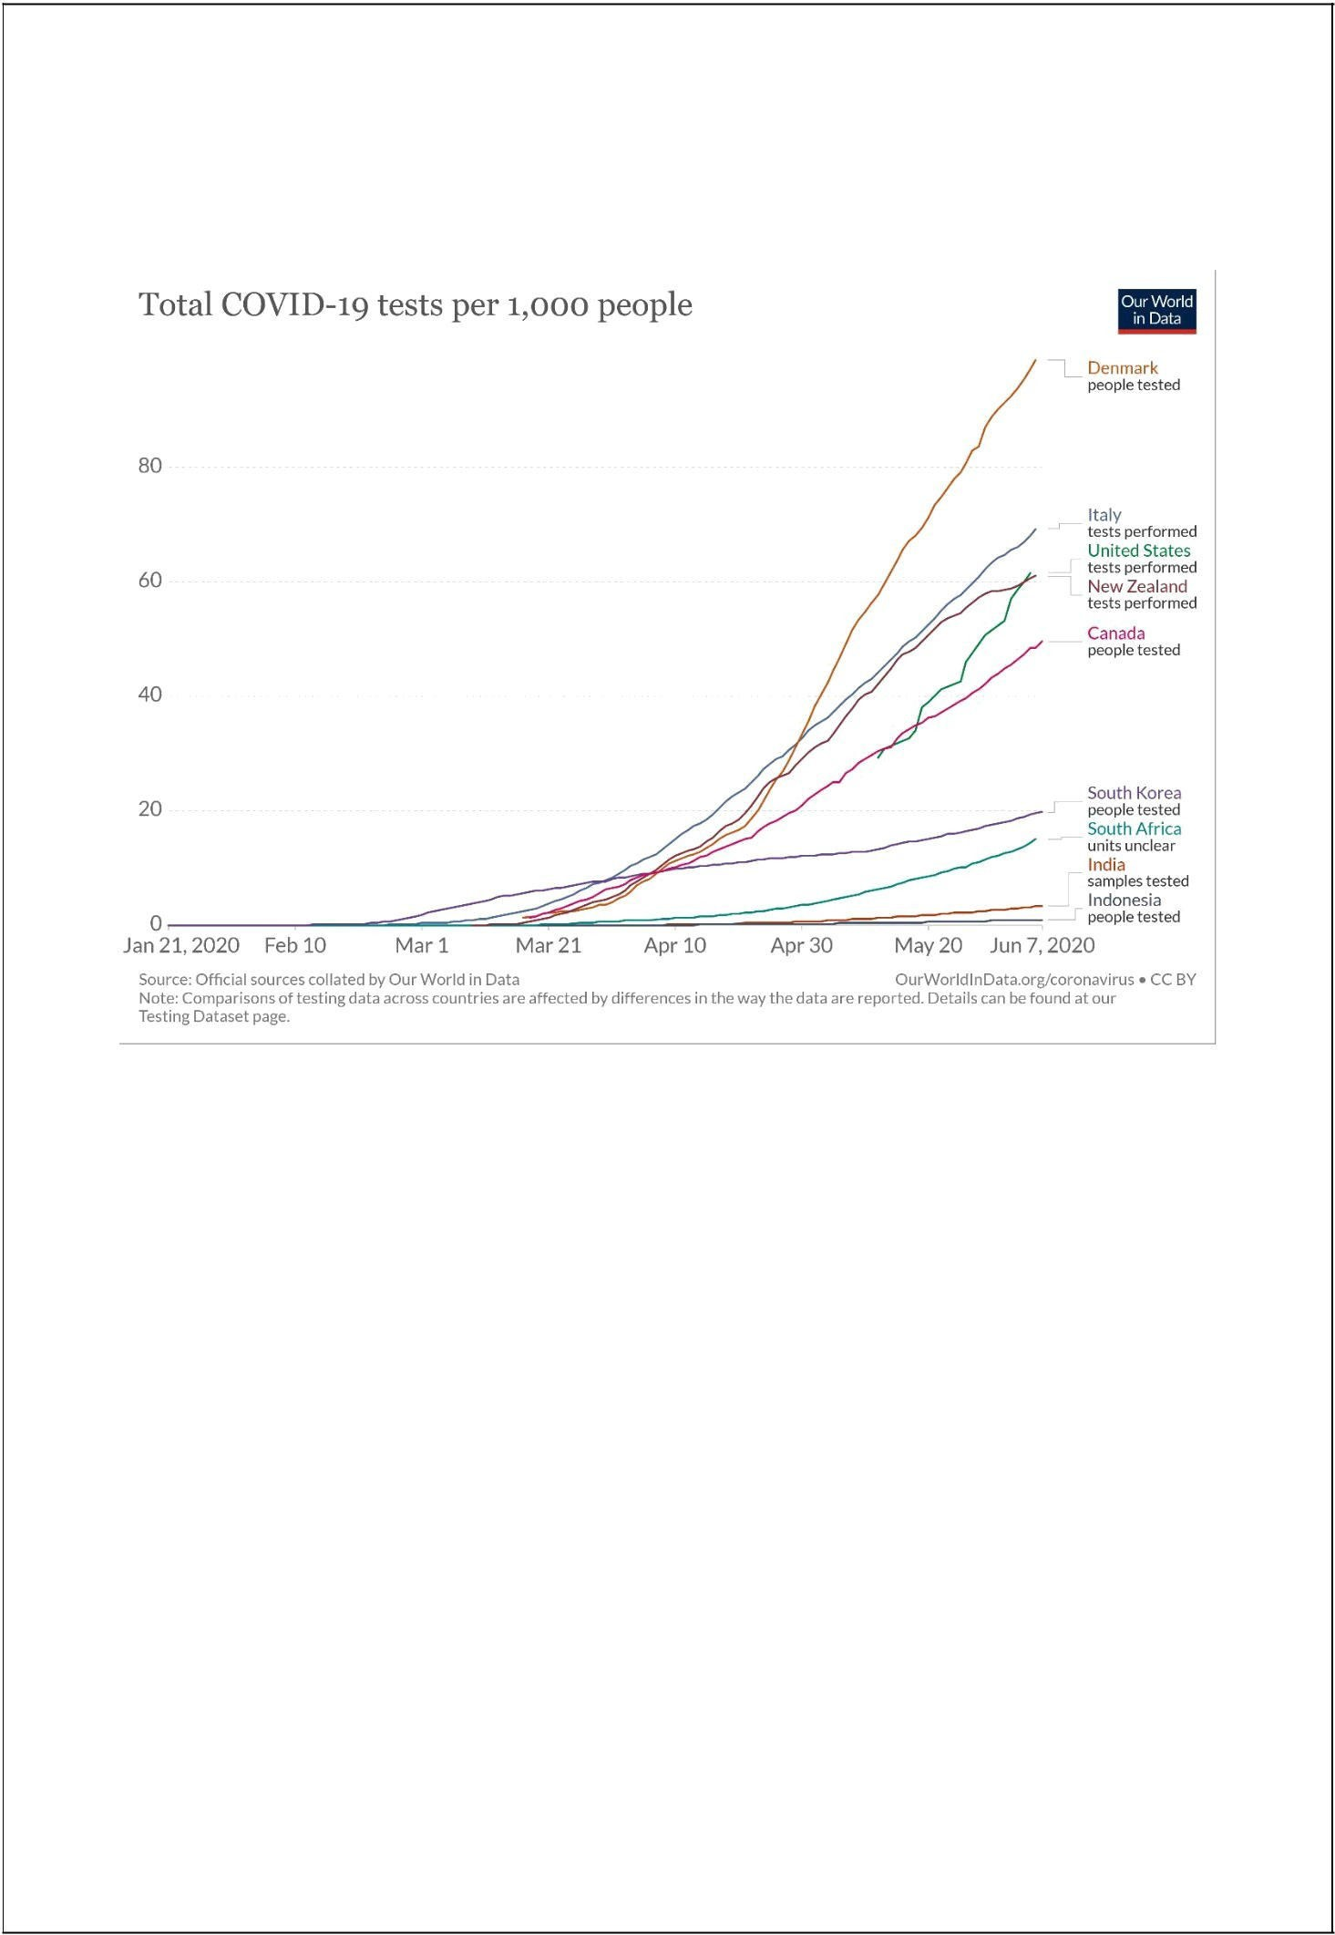
In India, there is highly criticized by experts or other persons for the less number of testing being conducted.

( Fig 4.4 )
(Image source: https://ourworldindata.org/grapher/full-list-cumulative-total-tests- per-housand?time=..)

As shown within the graph above India places itself at the tail-end of this comparison. Low number of tests conducted was the rationale reason behind at the lower end in world wide tally of COVID-19 cases in starting days of pandemic. But as of now we are observing 8-9 thousand people being found positive day by day.

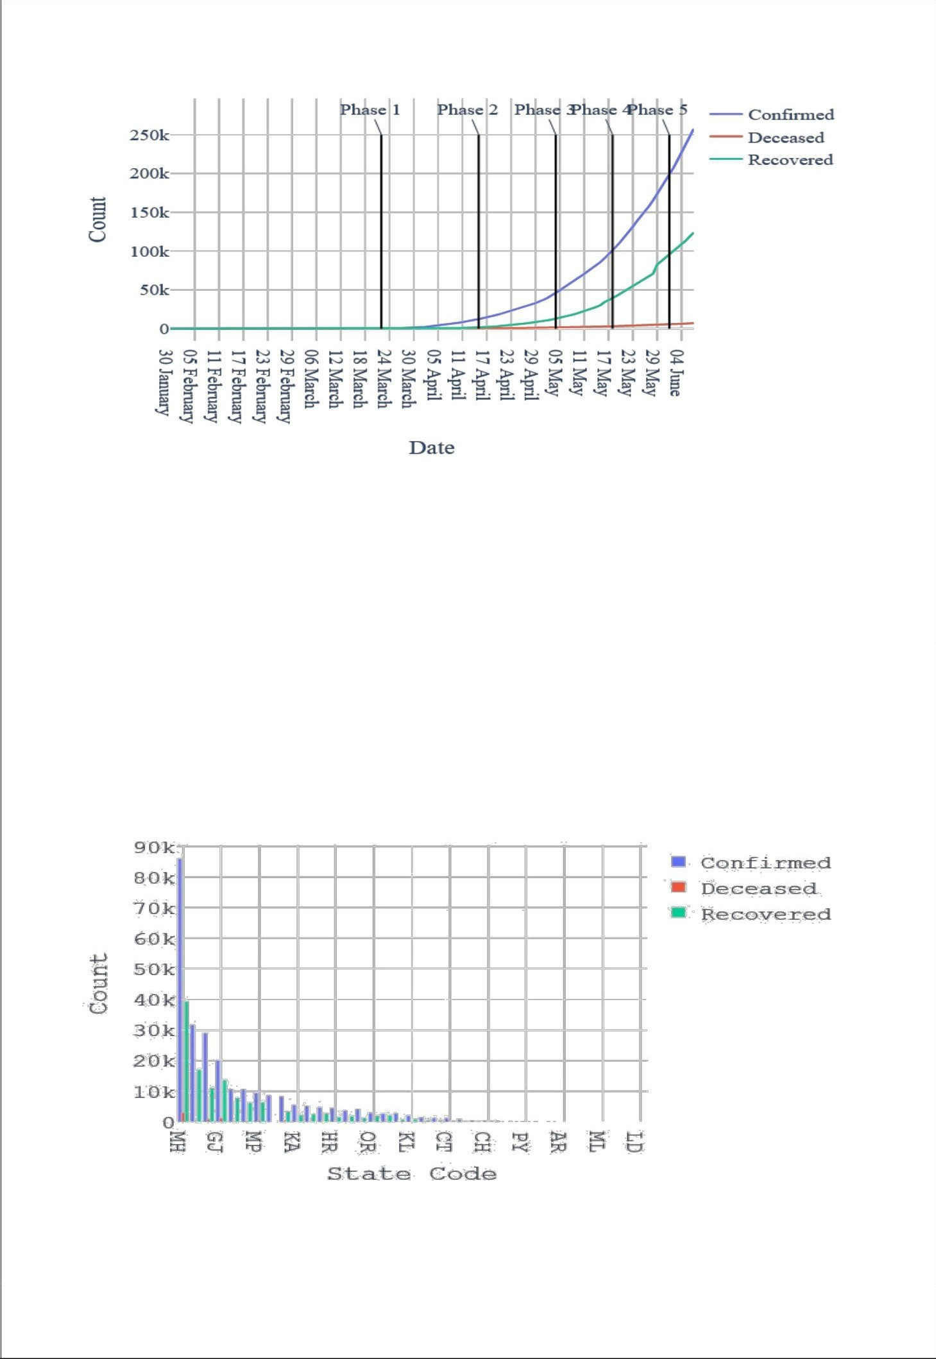

( Fig 4.5 )
As confirmed cases are increasing day by day the positive side is recovered number is also showing somewhat same behaviour with less number of people dying of COVID-19.India is yet to reach its peak of confirmed cases which is once reached then after that cases will start to decrease and recovered number will go higher to intersect confirmed cases at a point.

State-wise Comparison
India consist of 28 states and 8 Union Territories with varying features such as demography, geography, location, lifestyle etc. Which can decide the spread of contagious virus. Comparing COVID-19 situation in states gives us insight of which state/area is to be focused.

( Fig 4.6 )
As shown above, Maharashtra, Tamil Nadu, Delhi, Gujrat, Uttar Pradesh, Madhya

20
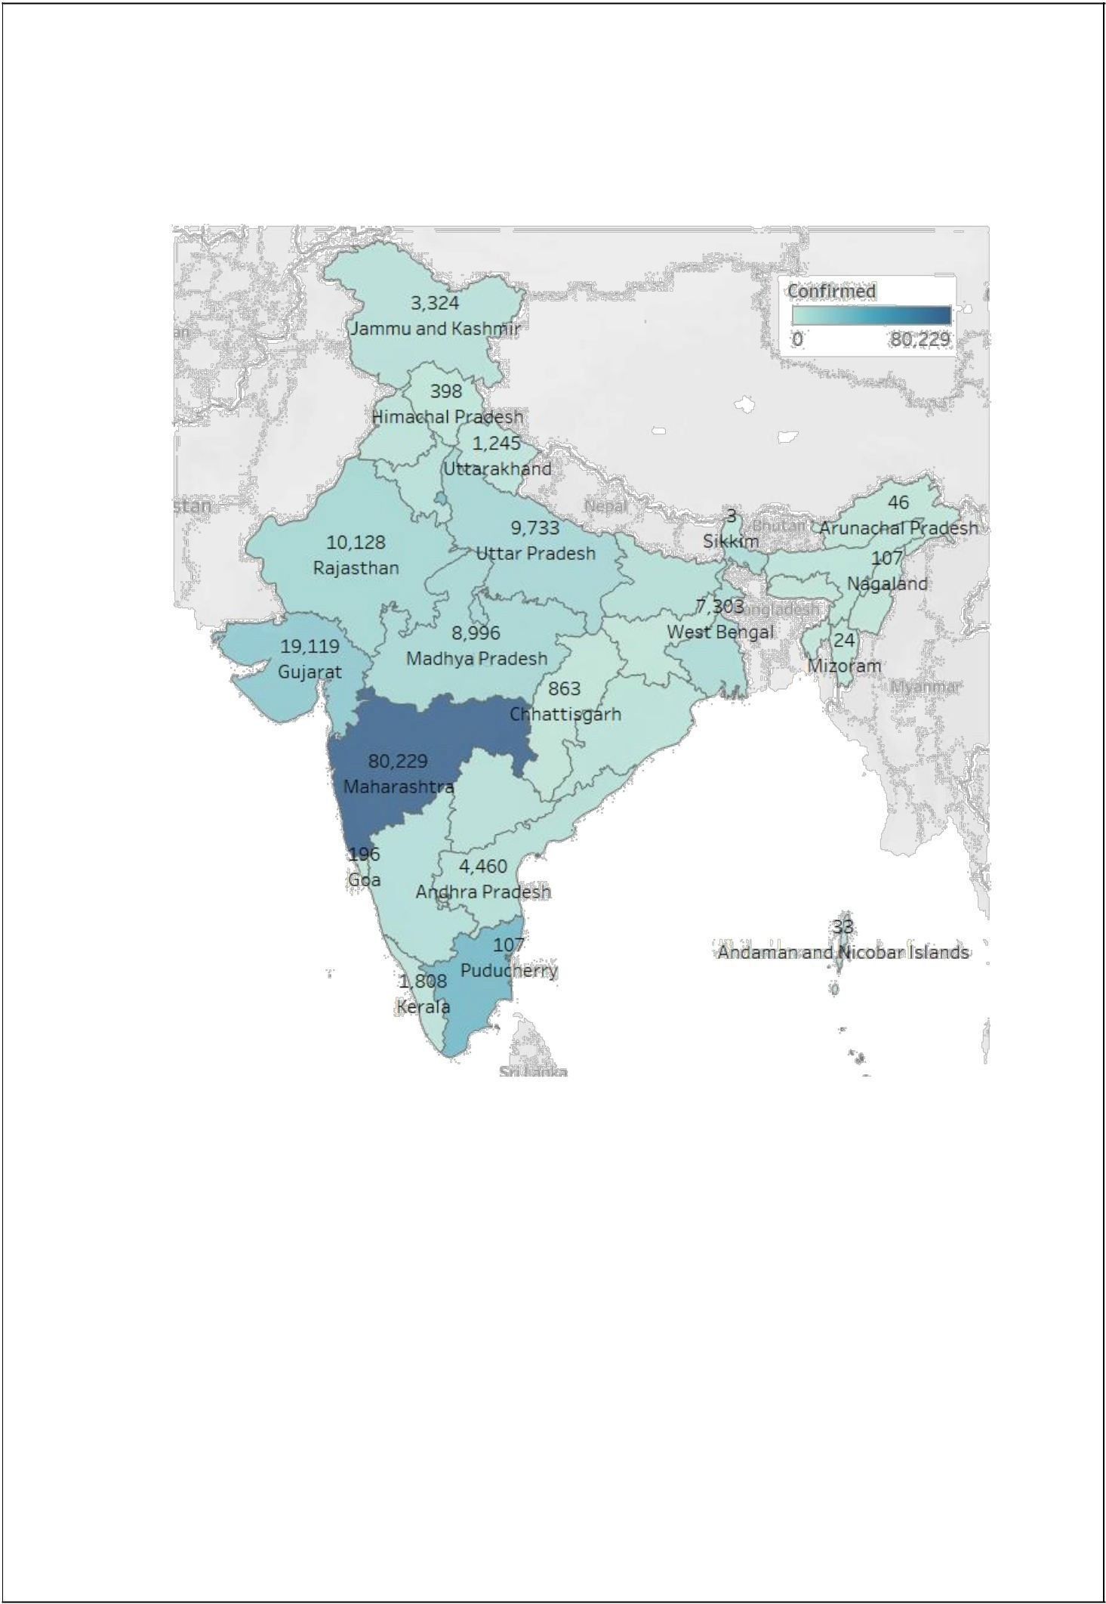
Pradesh are top 6 states in confirmed cases in India. When the cases started to be detected in India since that time only Maharashtra has been leading this tally. As of 5th June 2020, over 80,000 cases are confirmed in Maharashtra.

( Fig 4.7 )
We can see that more number of COVID-19 clusters are in left half part of the India. In the North-East region of India ,despite being close to China , there are very less number of confirmed cases. The possible reason of this variation is discussed later part of this analysis.

21
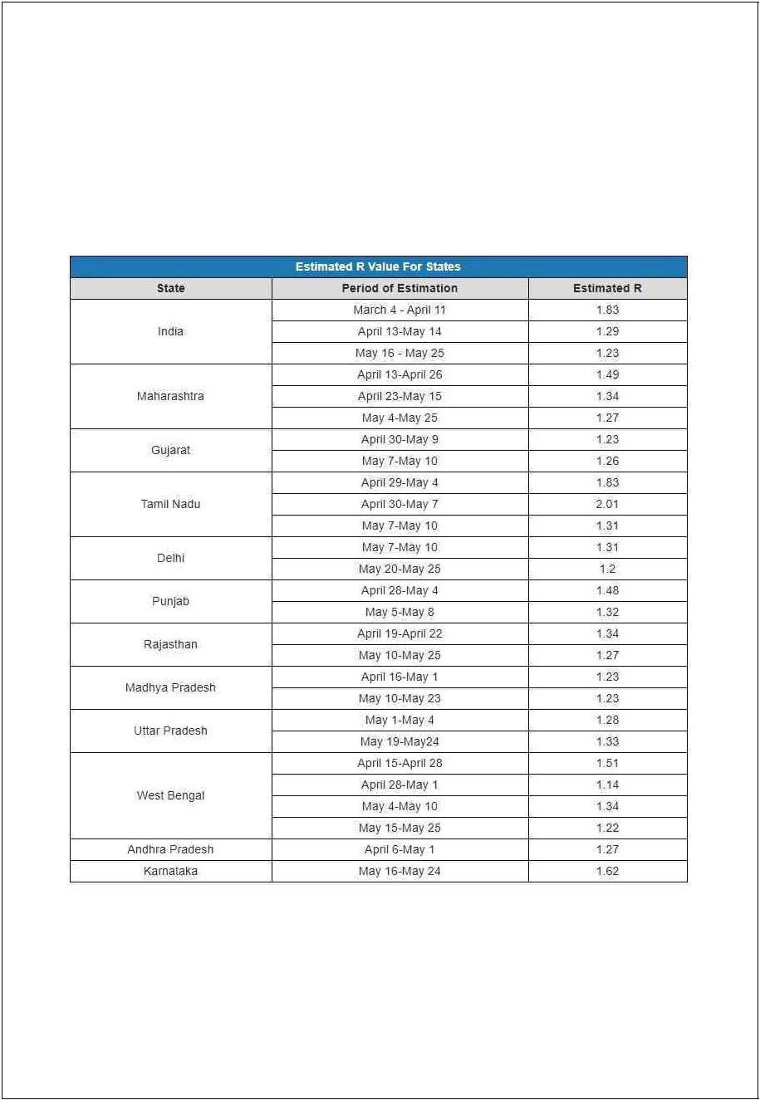
  - R0 FACTOR

The R0 factor also known as Basic Reproduction Number. The R0 factor of an area denotes how many more persons can be infected due to a person who is having the disease. If R0 is 1.2 then it means 1 infected person can infect 1.2 person by the same disease. So that 5 people can infect total 6 new persons (1.2*5=6.0).

( Fig 4.8 )

(Image source: https://scroll.in/article/963252/in-india-how-many-people-does-a- covid-19-patient-infect-on-average)

22
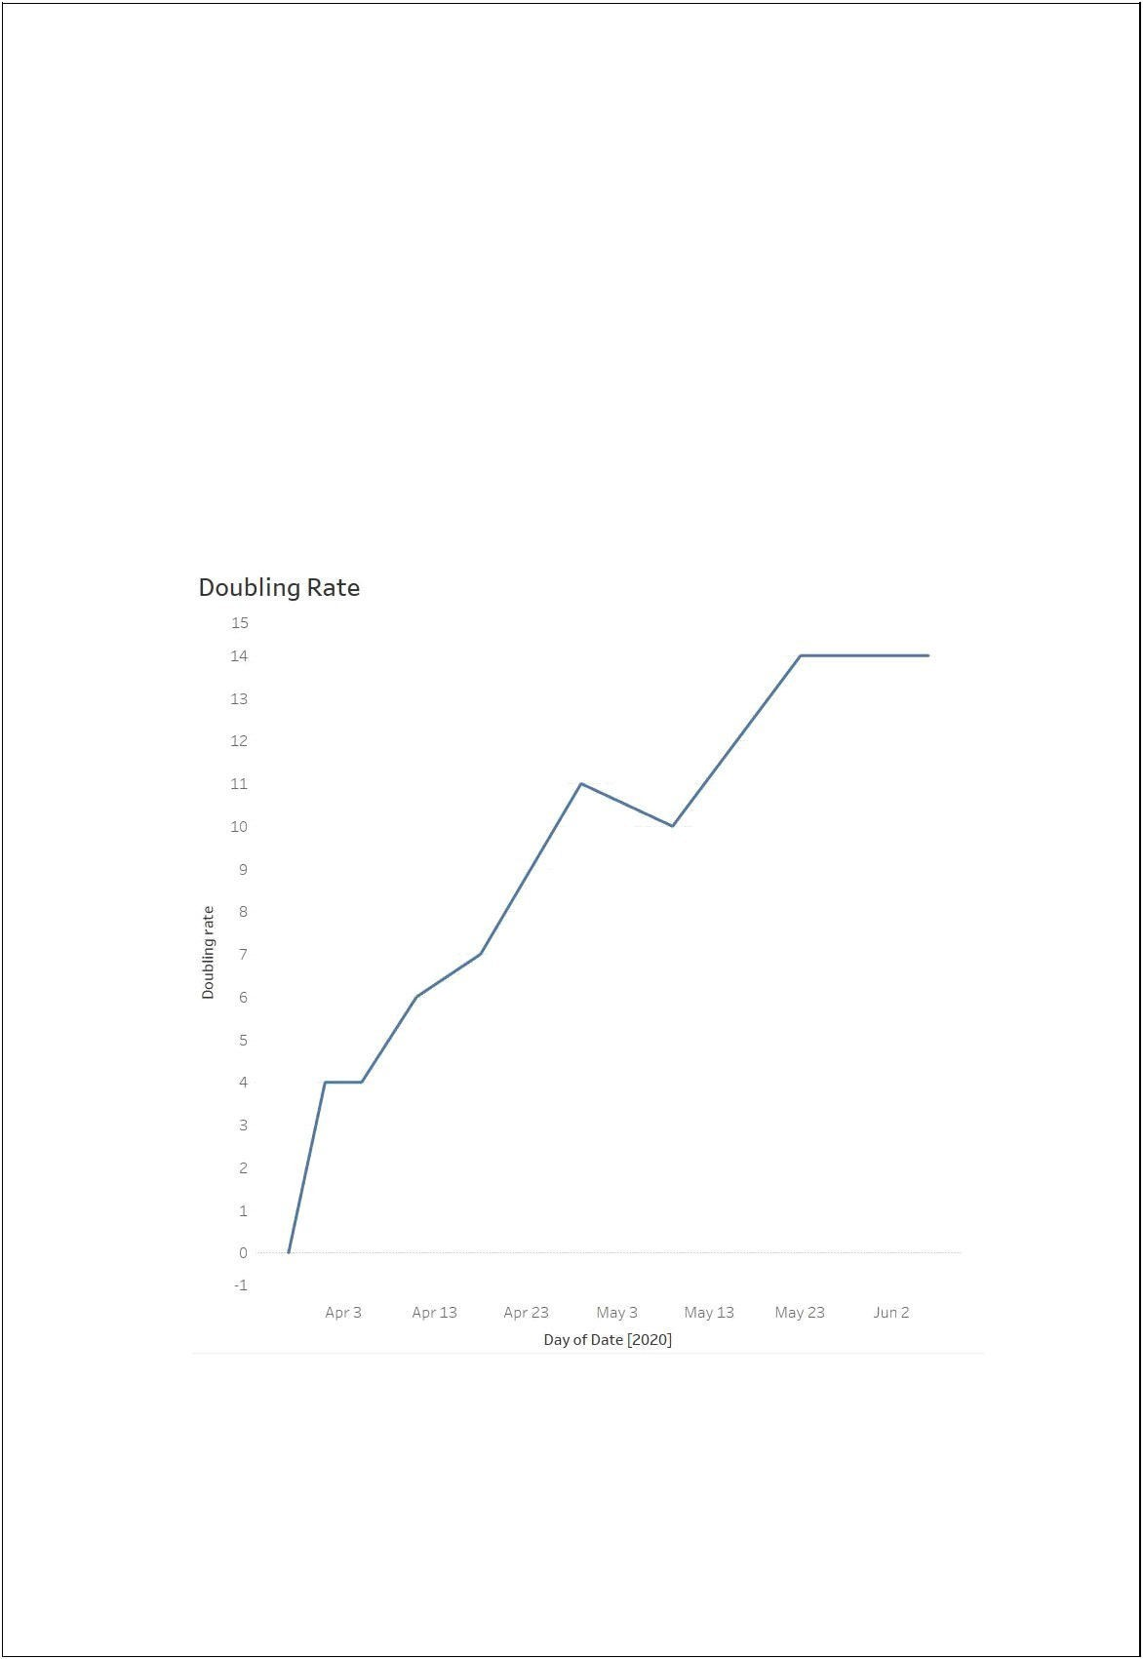
Its is believed that India is having steady R0=1.23 since 25th May which is still higher than normal. While imposing nation-wide lockdown R0 is considered as one of the factor . If the R0 values is less than 1 i.e. one infected person can not infect another person then lockdown is to be lifted. But Lockdown in India is being lifted in steps despite having R0 factor greater than
    - It could lead to drastic results in future.

  - DOUBLING RATE

Doubling rate is number of days taken to double the number of confirmed cases in a particular area. This number should be as large as possible. Large number of doubling rate will increase the hopes of situation under control.

( Fig 4.9 )

India is showing positive trend in doubling rate but the situation is still a not under the control of government and administration. This is a thing to worry about.

23
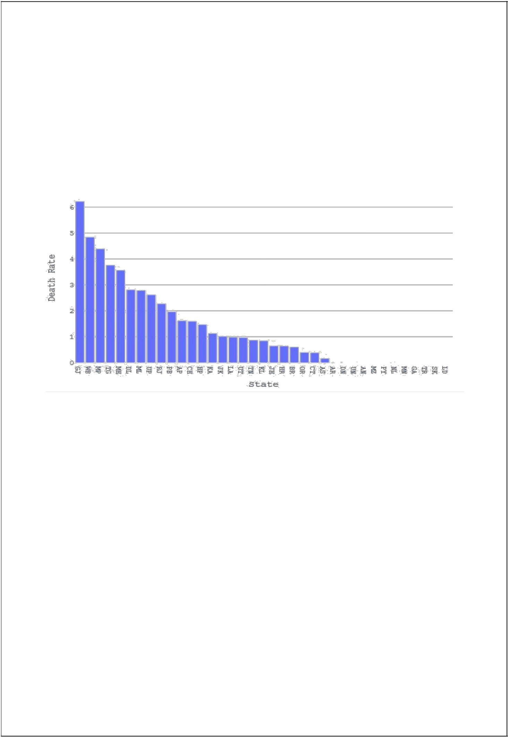
  - DEATH RATE
Death rate is calculated by,
100*(number of deaths in a state / number of confirmed cases in a state)

The number obtain after this calculation is the number of deaths behind every 100 confirmed cases in that state. Higher the number more the area is to be focused.

( Fig 4.10)

Gujrat is having death rate over 6 followed by West Bengal , Madhya Pradesh , Maharashtra , Telangana with death rates 5 , 4.2 , 3.5 , 3.4 respectively. Where as whole country’s death rate on 5th June 2020 is 2.78 .All the states/UTs with death rate more than 2.78 are to be taken care of more intensively.

24
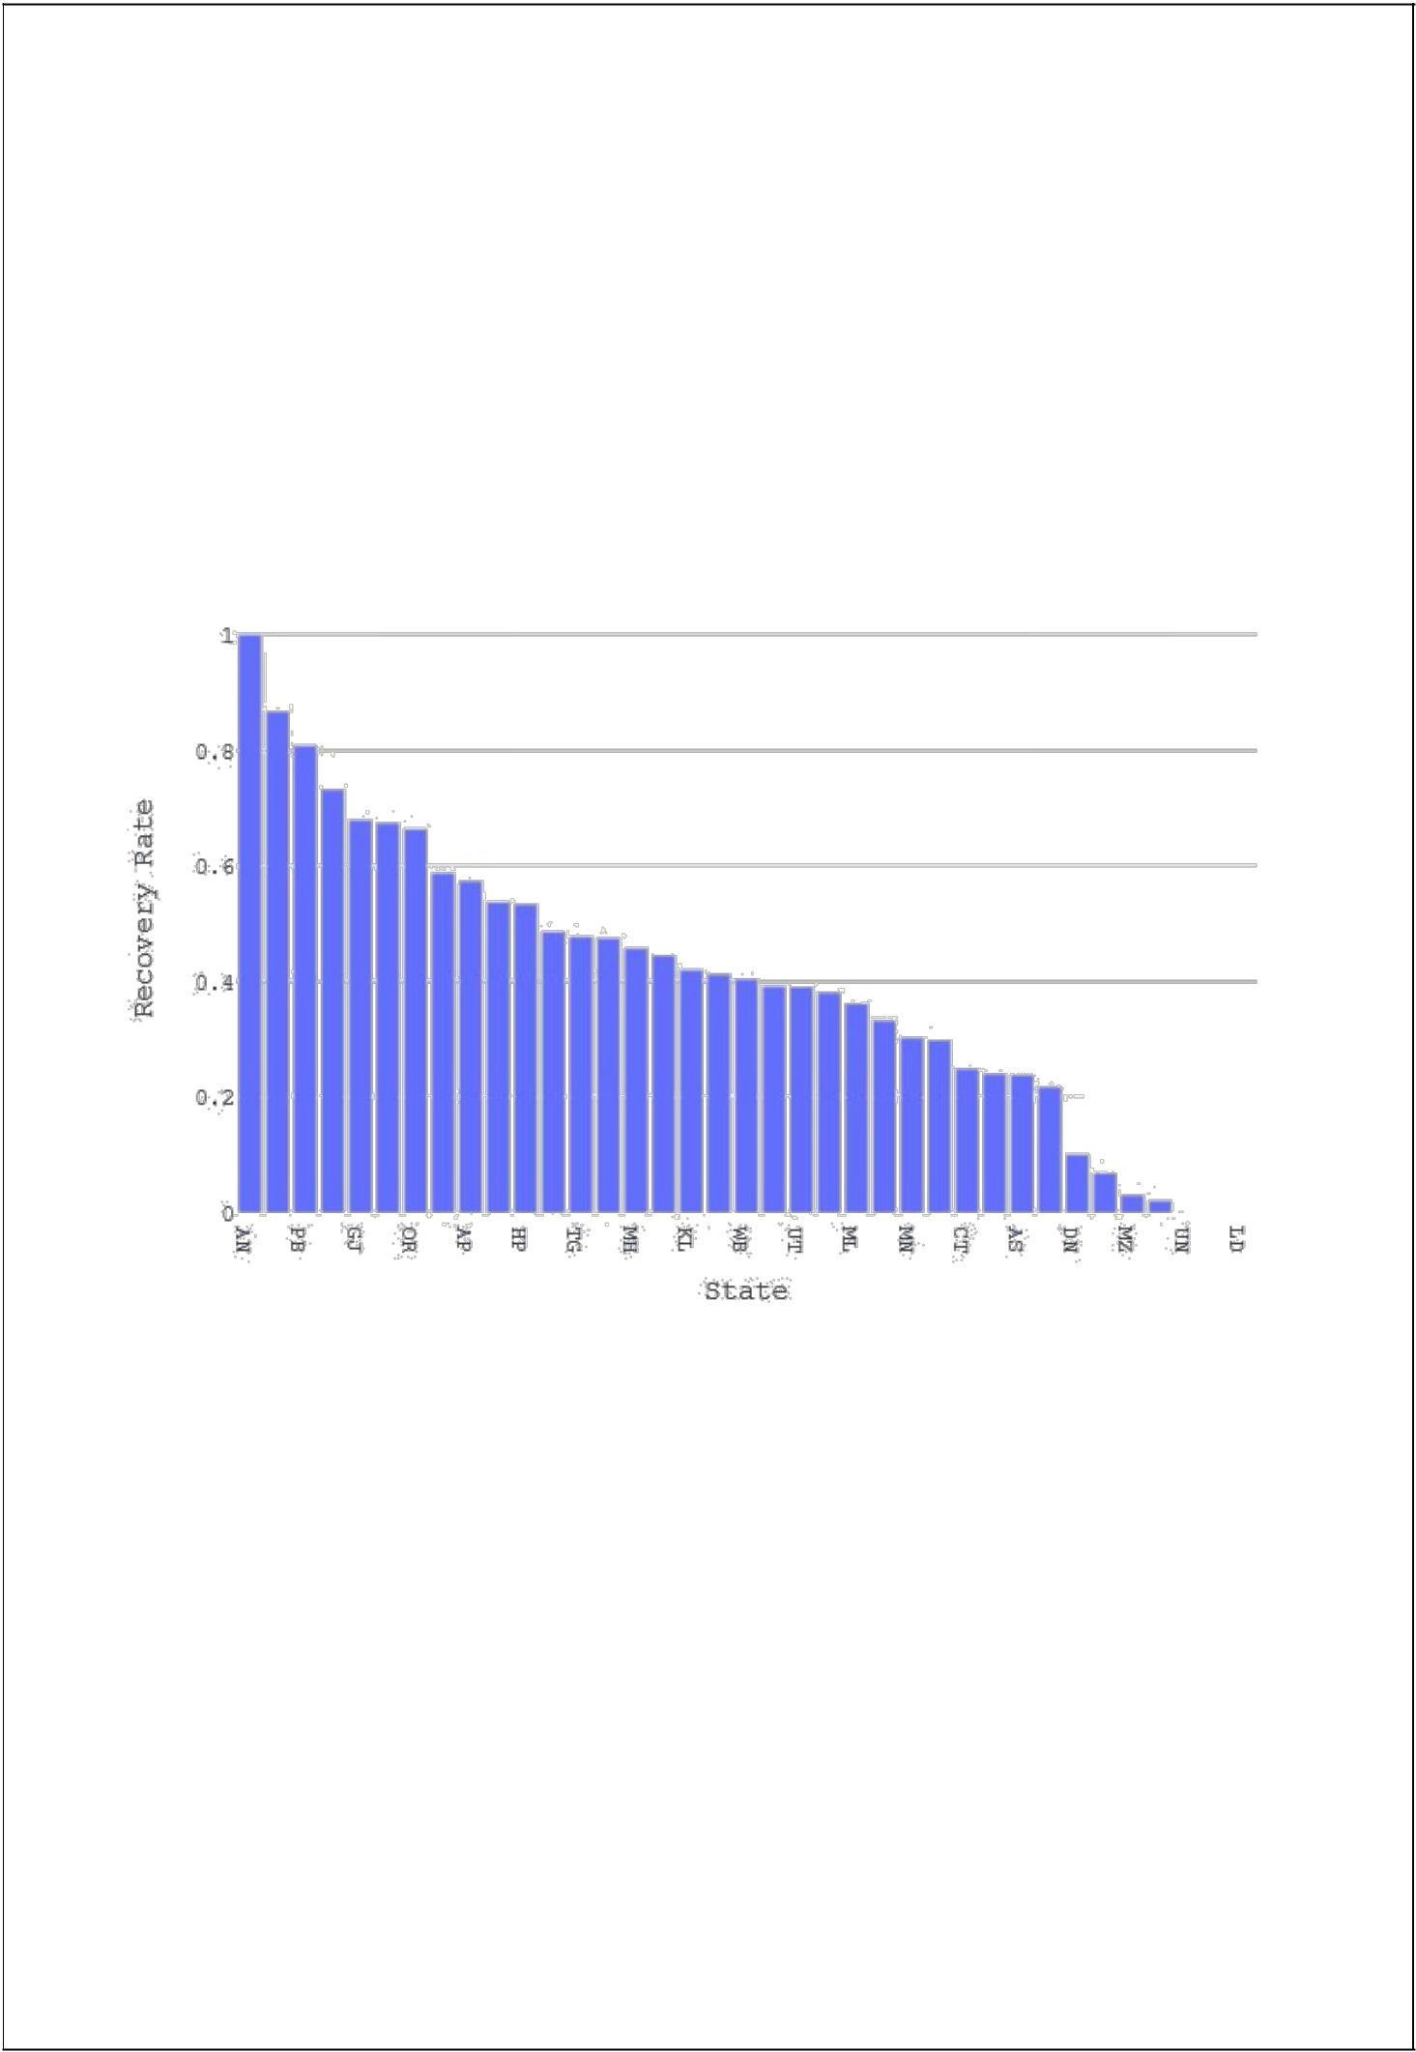

  - RECOVERY RATE
Recovery rate is calculated by,
100*(number of recoveries in a state / number of confirmed cases in a state)

The number obtain after this calculation is the number of recovered patients behind every 100 confirmed cases in that state.

( Fig 4.11 )

Chandigarh is having recovery rate close to 90 followed by Punjab, Rajasthan , Gujrat
,Madhya Pradesh with recovery rates 84, 72, 68, 65 respectively. Where as whole country’s death rate on 5th June 2020 is 47.48.

25
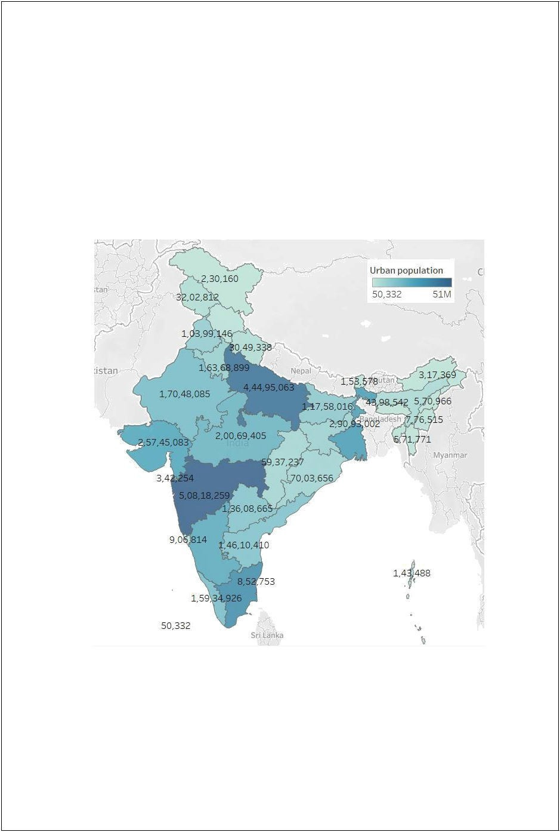
  - CLUSTER ANALYSIS

What could be the reasons behind cases clusters found in India.
    - URBAN POPULATION
As discussed earlier, there are more cases found in western part than the eastern part of India. We tried to find out some of the reasons that may have caused this situation in India.
India has 2nd most population in the world and places itself at 7th position in the tally of surface area. So somewhere population is going to be major factor in spread of such pandemic.

( Fig 4.12 )

Above is the map of India showing urban population in each state.
And Fig 4.7 is the graph showing confirmed covid-19 cases in each state in India . They both look somewhat similar indicating ‘More urban population causes quick spread of corona virus’. Top 8 States with highest urban population:

26
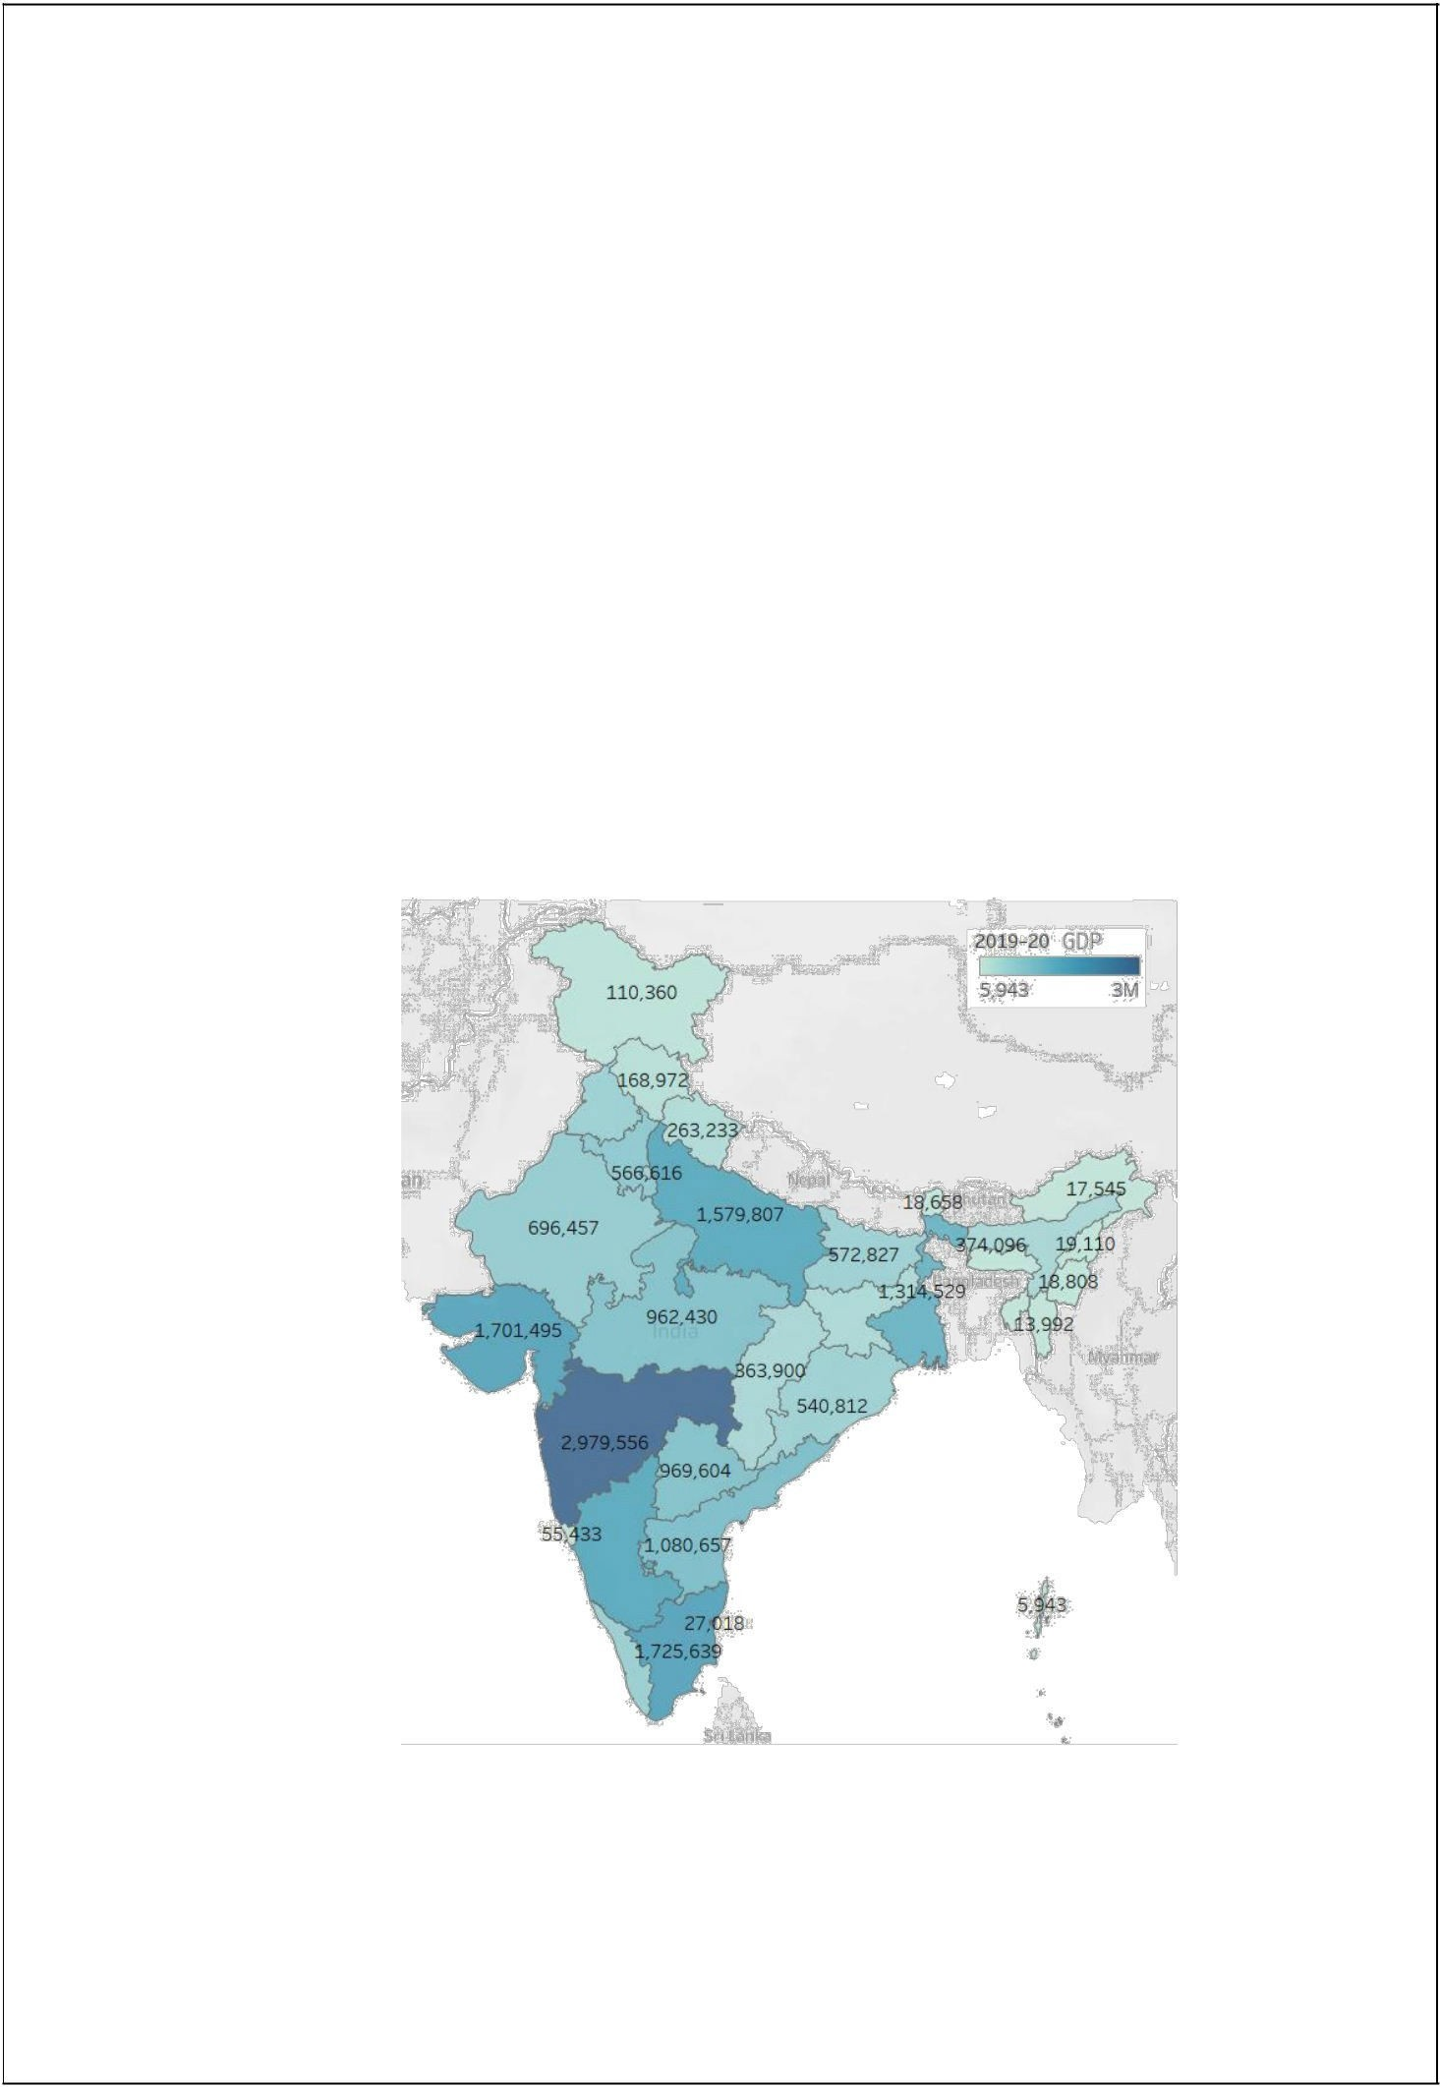
Maharashtra ,Uttar Pradesh, Tamil Nadu , West Bengal ,Gujarat, Karnataka ,Madhya Pradesh , Rajasthan.

Top 8 States with highest number of COVID-19 cases:
Maharashtra , Tamil Nadu, Delhi ,Gujarat ,Rajasthan , Uttar Pradesh ,Madhya Pradesh ,West Bengal.

Out of top 8 states 7 states are common in both category. This indicates more urban population in these states causing higher number of cases.

    - GDP CONTRIBUTION
India is the world’s 5th largest economy by nominal GDP. All states contributes in GDP of India.

( Fig 4.13 )
These are the figures of state and its GDP for the financial year 2019-20 in Crores.
Fig 4.7 graph is state and its confirmed COVID-19 cases. These two graphs too look somewhat

27
identical indicating that ‘Public movement , interaction ,contact with each other in activities which contribute in GDP, causes a favourable environment for the spread of such viruses.’

Top 8 States with highest GDP:
Maharashtra , Tamil Nadu, Gujarat, Karnataka, Uttar Pradesh ,West Bengal , Andhra Pradesh ,Telangana

Top 8 States with highest number of COVID-19 cases:
Maharashtra , Tamil Nadu, Delhi ,Gujarat ,Rajasthan , Uttar Pradesh ,Madhya Pradesh ,West Bengal.

The comparison above showing out of top 8 states 5 states falls in both of the category, Which indicates that if more number of businesses running in a state the more will such viruses spread in that state. Pandemics like COVID-19 hits the economy building factors the most.

28

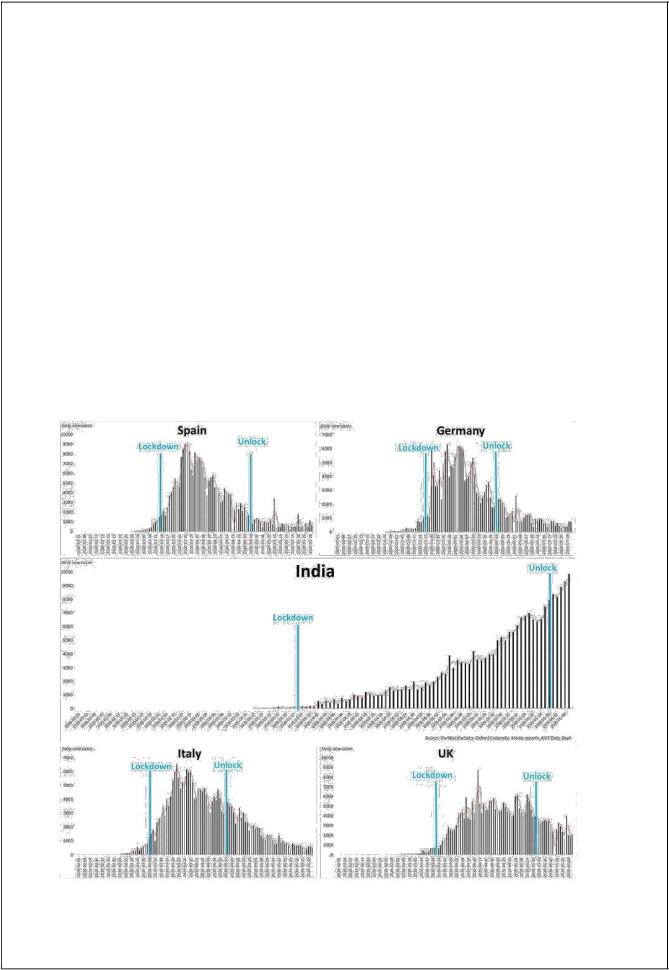
4.7 LOCKDOWN
Is lockdown in India a successful or not?
Indian government implemented lock down in 4 phases. In comparison with other countries , India declared lockdown in its early days of COVID-19 outbreak.
Phase 1: 25th March – 14th April Phase 2: 15th April – 3rd May Phase 3: 4th May – 17th May Phase 4: 18th May – 31st May
Among which phase 1 and 2 of lockdown were very strict whereas phase 3 and phase 4 were comparatively lenient.

In all 4 phases of lockdown, not a single lockdown showed any down falling of the curve and yet India has not reached the peak yet.

( Fig 4.14 )

29
In all the phases of lockdown in India , cases graph is showing increasing trend only.
Lockdown was meant to find a peak of cases in India but it failed to do so. When we compare India’s lockdown phase with other country’s lockdown phases , we see India loosing with great margin.
As per experts’ analysis we are still very far from a peak which is quite scary. Lockdown in India did not serve its purpose and caused economic harm as well as non-decreasing cases in India.

CHAPTER 5

CODING SECTION SCREENSHOTS
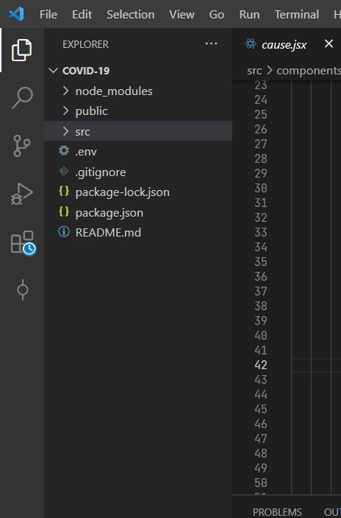
Lets illustrate Coding and screenshots section. In this section you will see how our app is looks like

Here you can see the structure of app. As you can see there are three folders as node_modules, public and src or some files
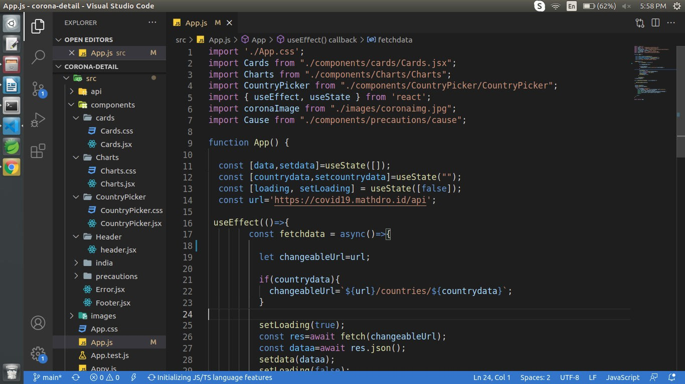
App.js File ----

App.js is main component of this app . We have define our api in this file , and we can say that our all component call in this File.
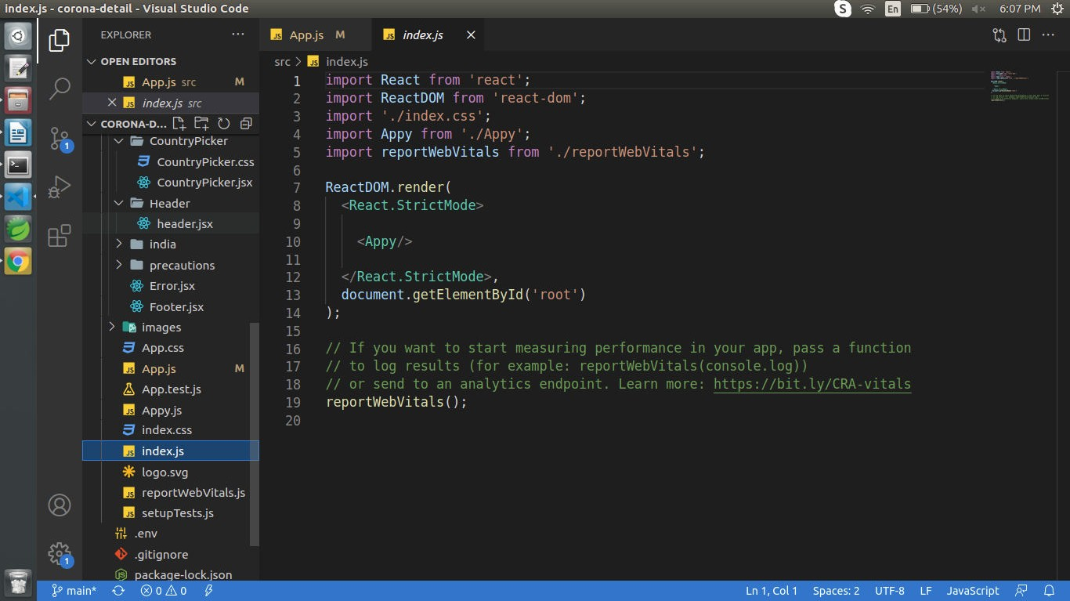
Index.js File ----

It imports our App. js component which tells React where to render it (We will find this div element in our index. html file). To be more concise, react is for the components and react-dom is for rendering the components in the DOM. 'react-dom' acts as a glue between components and DOM
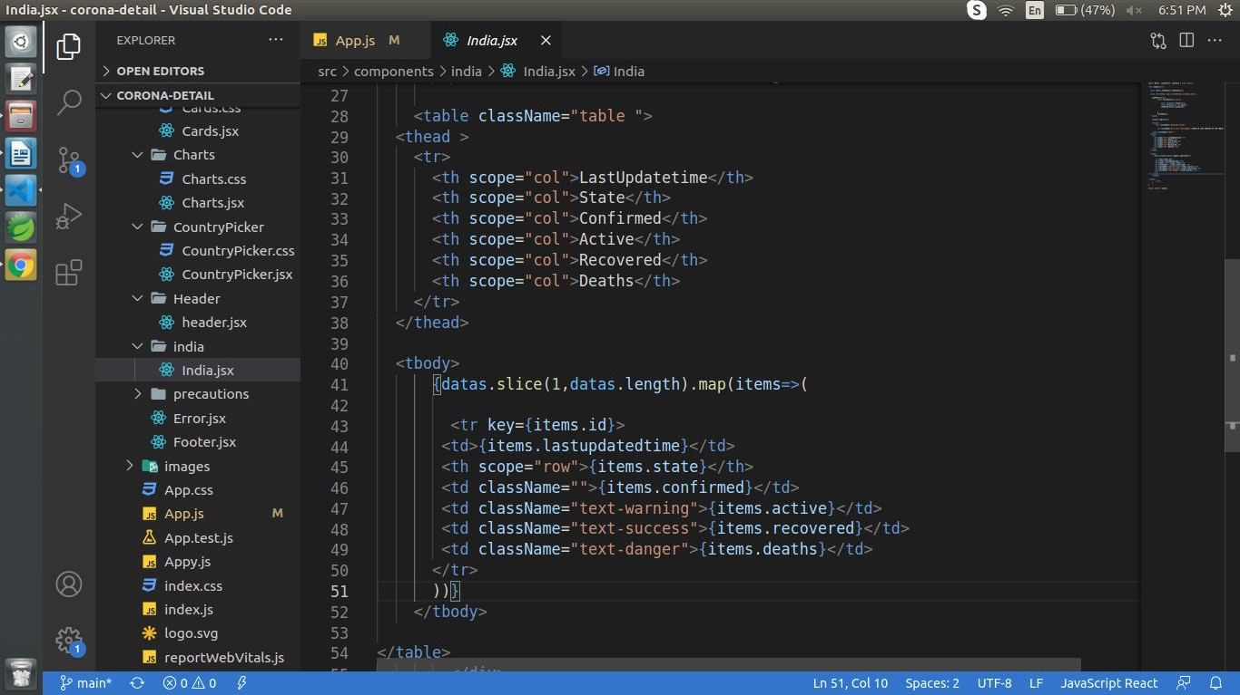
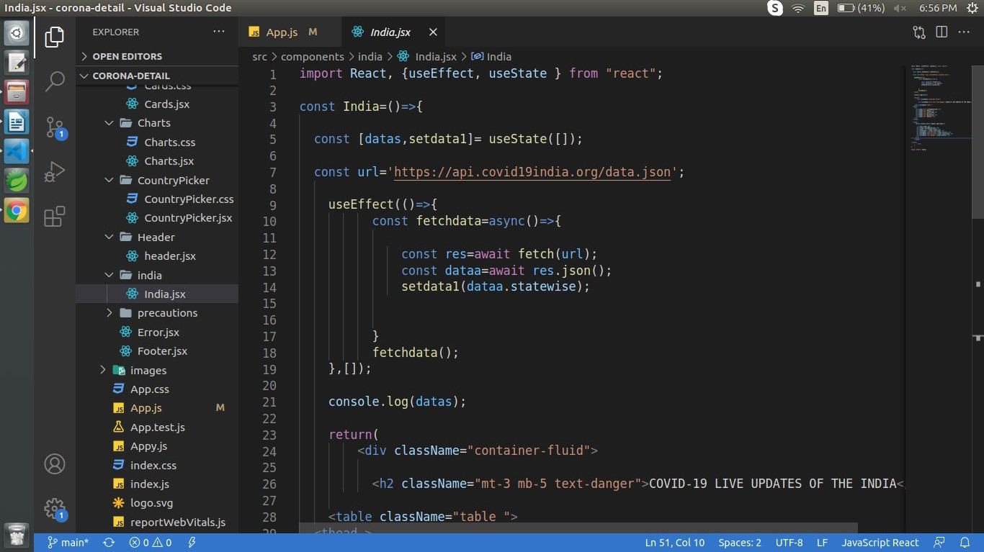
India covid Cases File -----

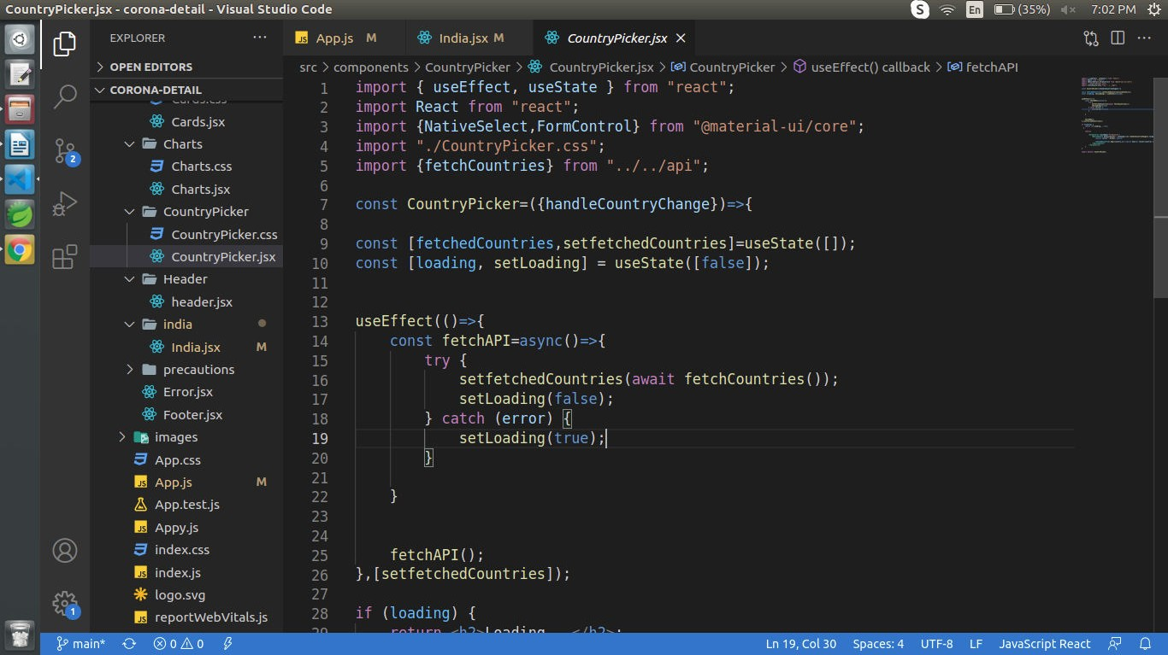
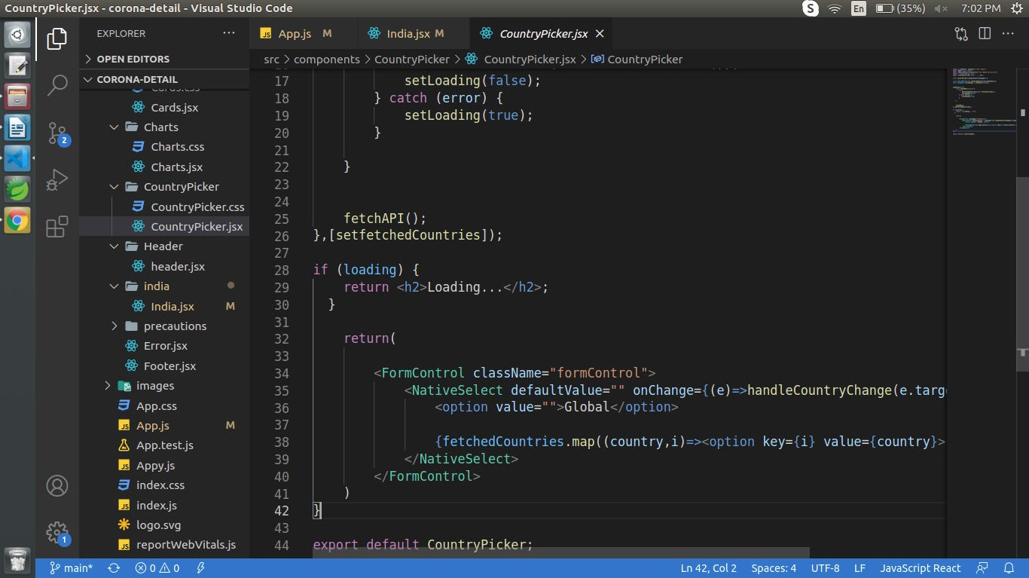
Country Picker Module code ----
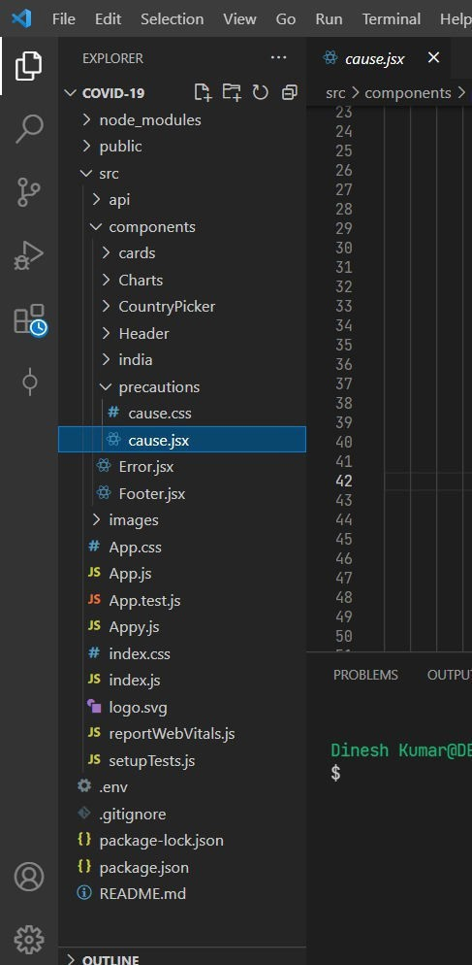
Above is the complete folder structure of app.

The first step follows the rule: One file to rule them all. Most React projects start with
a src/ folder and one src/App.js file with an App component. At least that's what you get when you are using create-react-app. This App function component just renders something:
Eventually this component adds more features, it naturally grows in size, and needs to extract parts of it as standalone React components. Here we are extracting a React list component with another child component from the App component:
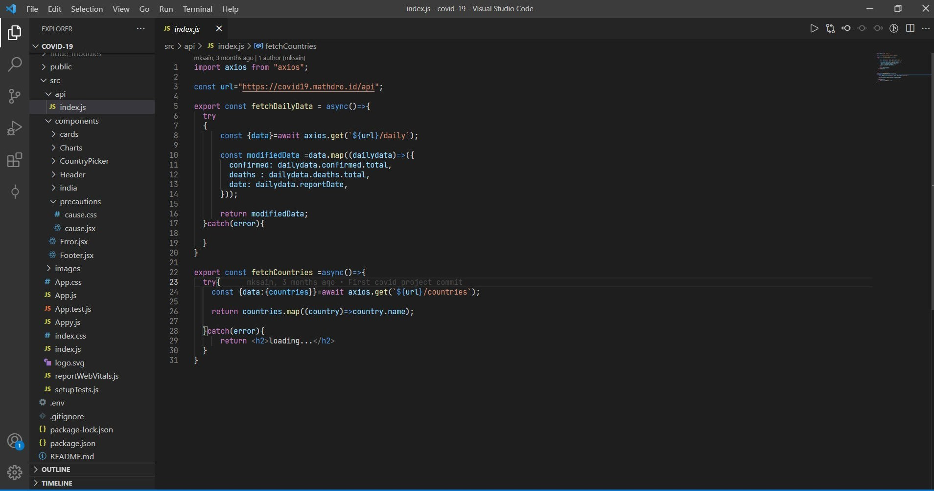
This is coding ofAPI
API is know as Application programming interface. It is an interface that An application programming interface (API) is a connection between computers or between computer programs. It is a type of software interface, offering a service to other pieces of software.[1] A document or standard that describes how to build such a connection or interface is called an API specification. A computer system that meets this standard is said to implement or expose an API. The term API may refer either to the specification or to the implementation.
In contrast to a user interface, which connects a computer to a person, an application programming interface connects computers or pieces of software to each other. It is not intended to be used directly by a person other than a computer programmer who is incorporating it into software. An API is often made up of different parts which act as tools or services that are available to the programmer. A program or a programmer
that uses one of these parts is said to call that portion of the API. The calls that make up the API are also known as subroutines, methods, requests, or endpoints. An API specification defines these calls, meaning that it explains how to use or implement them.
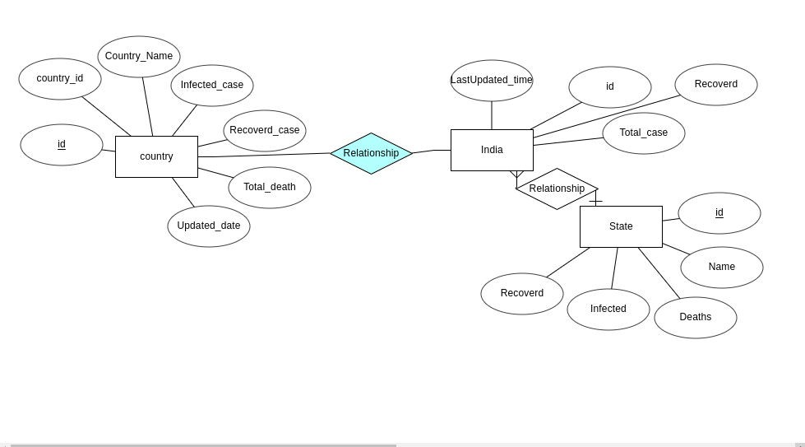
  - diagram
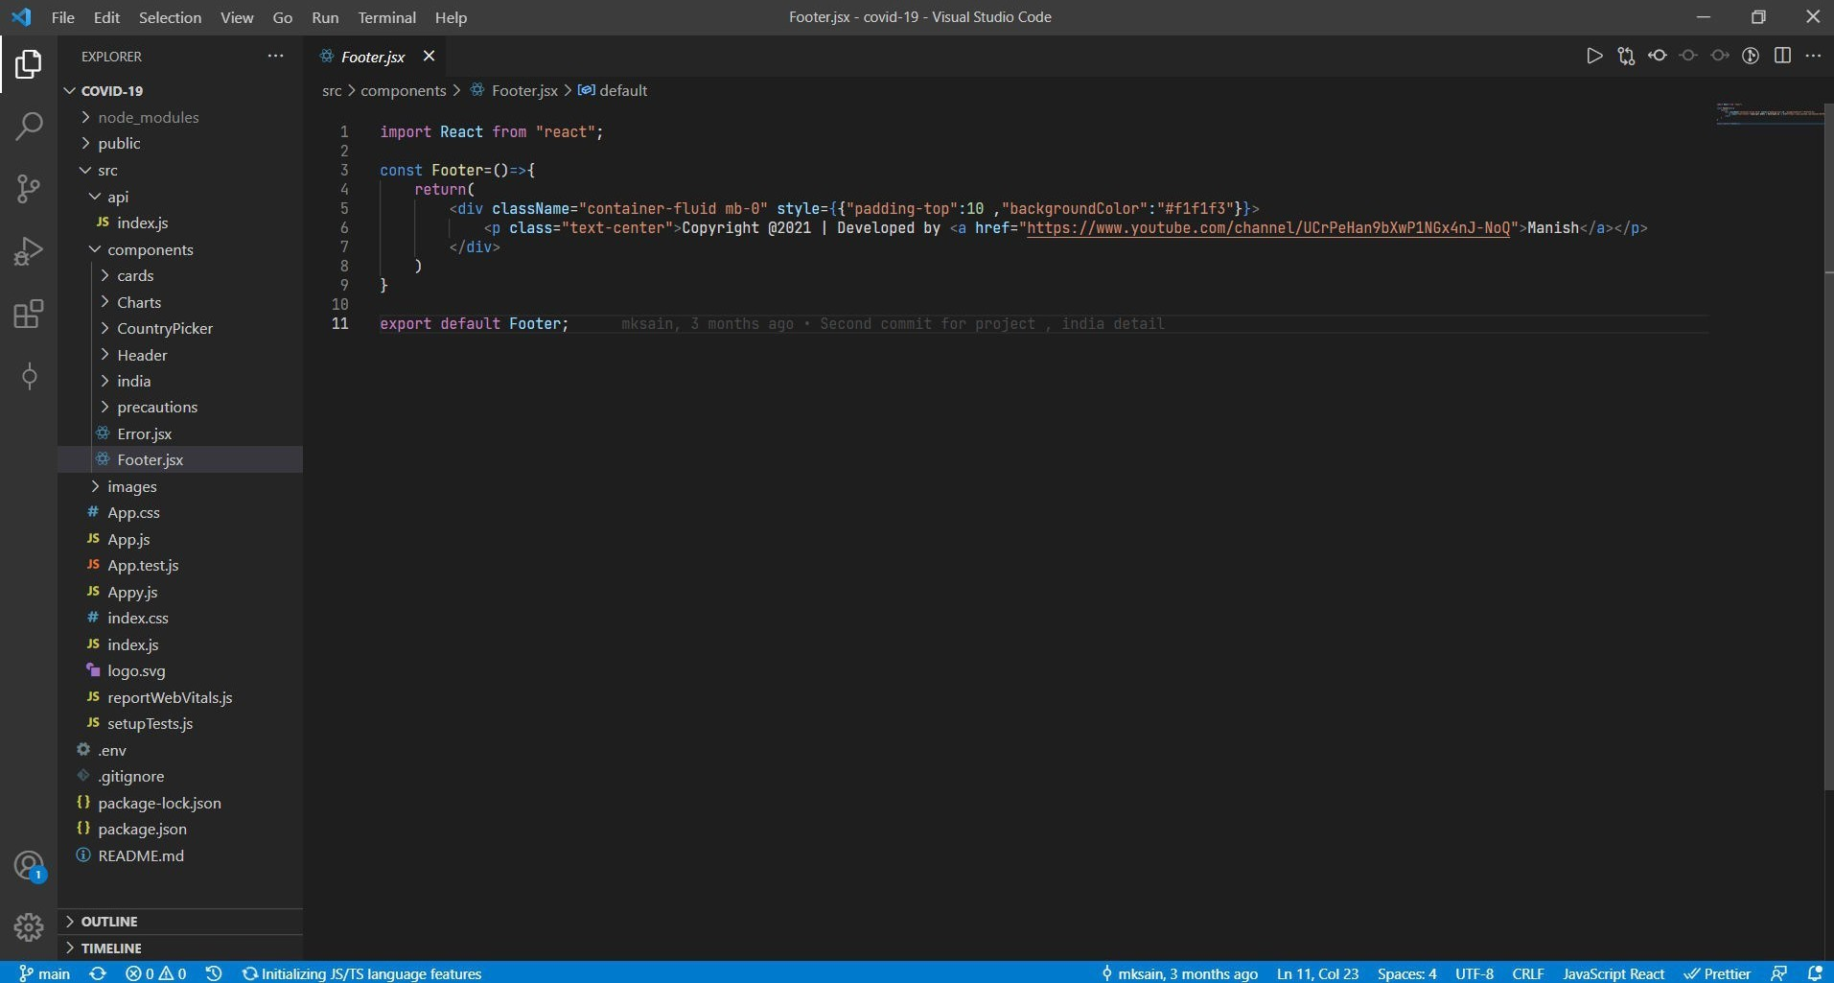
Footer of app.
Footer is a bottom part of appAs UX professionals, we tend to dedicate our time and energy to everything above the fold. That’s because global navigation, search, and high-priority content are positioned above the fold and users tend to spend
a disproportionate amount of their time at the top of any given page. Consequently, footers, which appear at the bottom of web pages, get the short end of the UX time and resource budget. However, you should still pay attention to footers because they can greatly enhance a user’s experience.

Definition: A website’s footer is an area located at the bottom of every page on a website, below the main body content.

The term “footer” comes from the print world, in which the “footer” is a consistent design element that is seen across all pages of a document. However, as we explained 20 years ago, the difference between print design and web design means that design elements like footers change their meaning (in this case by becoming actionable) when they’re ported from print to online.
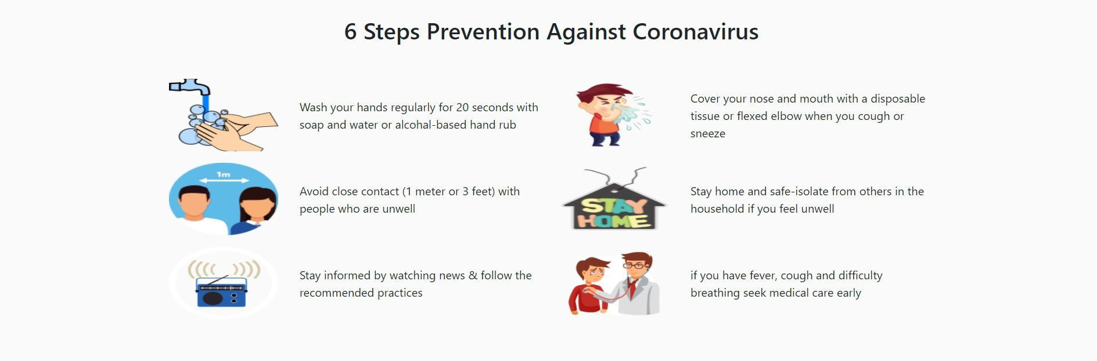
Covid-19 Prevention By 6 Steps

    - Maintain at least a 1-metre distance between yourself and others to reduce your risk of infection when they cough, sneeze or speak. Maintain an even greater distance between yourself and others when indoors. The further away, the better.
    - Make wearing a mask a normal part of being around other people. The appropriate use, storage and cleaning or disposal are essential to make masks as effective as possible.

Here are the basics of how to wear a mask:

- Clean your hands before you put your mask on, as well as before and after you take it off, and after you touch it at any time.
- Make sure it covers both your nose, mouth and chin.
- When you take off a mask, store it in a clean plastic bag, and every day either wash it if it’s a fabric mask, or dispose of a medical mask in a trash bin
- Don’t use masks with valves.
Mobile View Of App -

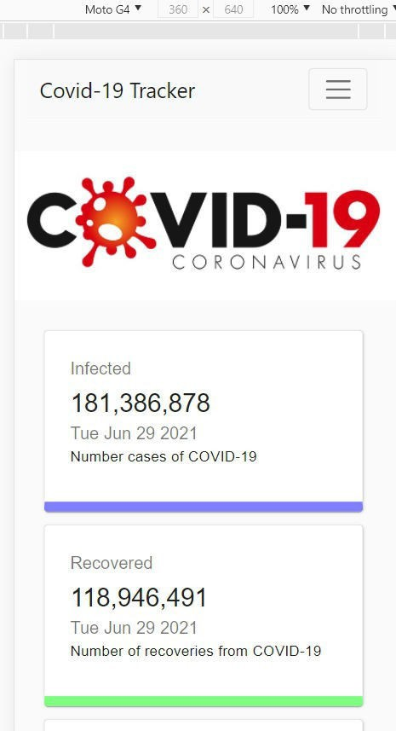

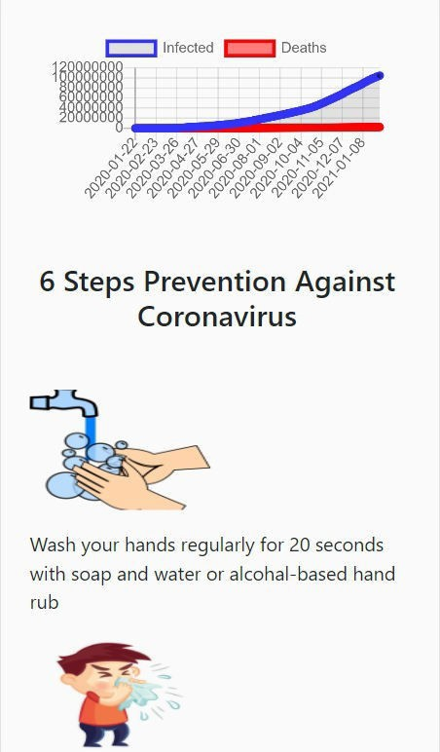

CHAPTER 6

CONCLUSION & FUTURE ENHANCEMENT

31

  - CONCLUSION

    - India is now 6th largest confirmed cases of COVID-19 in the world.
- India has not reached the peak yet so as of now we cannot predict the approximate number of confirmed cases in India.
- Recovery rate of India is also showing exponential behavior same as confirmed cases. But if cases increase beyond certain point then thing can go out of control which will affect the recovery rate.
- Gender information of most of the patients is nor released by the government but whatever data is available shows number of infected males is more than that of females. This is may be due to more exposure/contact of males with outdoor world.
- Same as gender, age information is unavailable for most of the patients , but whatever data is available shows age and cases are normally distributed and 21-40 is the age bin which has been infected more.
- This analysis showed that pandemic like this affects economy the most. Whichever the country’s GDP source is , it gets targeted the most. Slowing down the economy then unemployment, job losses and then this chain reaction continues.
- India was in lockdown for more than 2 moths but still situation did not get any better. This may be due to weak administration or the violation of lockdown by citizens.

32

5.1 FUTURE ENHANCEMENT

- Prediction Model
India has not reached the peak yet , once it reaches the peak the prediction model can be built to show that how much time it will take to get things back to the normal.

- Sentiment Analysis
India has never experience such pandemic in last 100 years so what do people think about this pandemic, lockdown , government approach/policies etc can be studied to have sentiment insight of this pandemic.
  - REFERENCE BOOKS
    - Mastering Python For Data Science : Samir Madhavan
    - Learning With Python

  - WEBSITE
    - https://api.covid19india.org

    - www.wikipedia.com

    - www.twitter.com .

    - https://www.w3schools.com/

    - https://stackoverflow.com/

    - https://plotly.com/

    - https://www.pythonanywhere.com/

33

